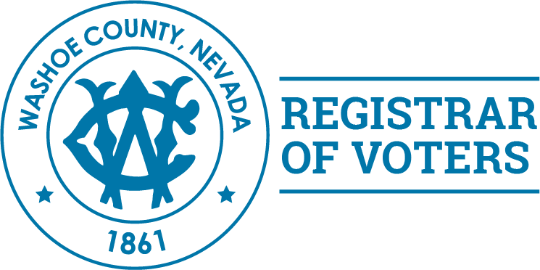

*Voting Information for*

*College Students*

**As a full-time college student you have a choice to make regarding your voting status. Remember – Voter**

**registration is done on a county-by-county basis**

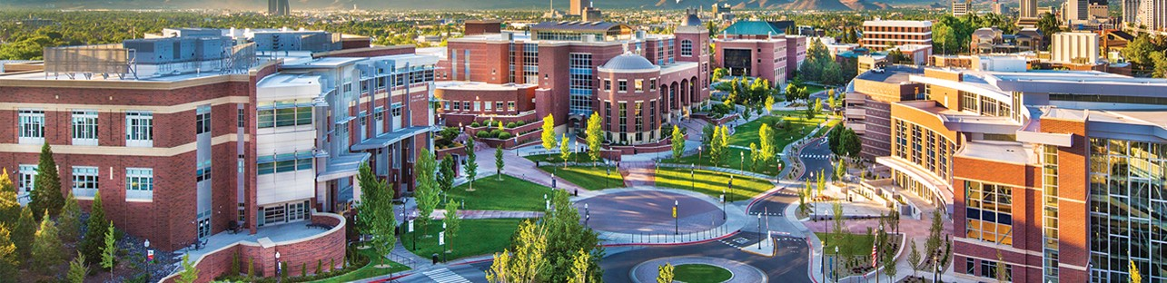



**Washoe County**

**Registrar of Voters**

1001 E 9th Street

Bldg. A, Room 135

Reno, NV 89512

Call or email the Washoe County Registrar of Voter’s Office

if you need assistance or have any questions or concerns

(775) 328-3670

[electionsdepartment@washoecounty.us](mailto:electionsdepartment@washoecounty.us)

Web Address

[www.washoecounty.us/voters](http://www.washoecounty.us/voters)

O**n-line Registration**

[**www.registertovotenv.gov**](http://www.registertovotenv.gov)

* Do you wish to register to vote in the county **where you go to school** – in your case, Washoe County, Nevada?
  + Register On-Line – you must have a Nevada Driver’s License or

Nevada ID Number and a Social Security Number

* + Pick up a form at the Student Union or Post Office, fill it out

completely (DON’T FORGET A VALID MAILING ADDRESS) and mail it to the Washoe County Registrar of Voter’s Office **(mail-in postmark deadline is October 9, 2018)**

* Would you prefer to be registered **at your permanent home,** outside of Washoe County?
  + Register to vote through the County Clerk or Registrar of Voter’s Office in the County you are from. **Don’t forget to request an absentee ballot – in writing – from your County – well in advance of the next election.** That is the only way you will be able to vote if you are registered anywhere other than Washoe County, Nevada.

**Don’t let the next election sneak up on you – register today!**

**You Have a Choice**

**Your Voice – Your Vote**