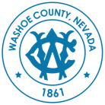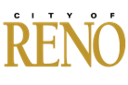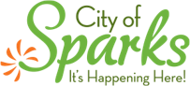
NOTICE OF PUBLIC INFORMATION AND INPUT SESSION
Regional Fire Services Study
Thursday, March 19, 2026 6:00 PM
Northern Nevada Public Health Conference Room A/B
1001 E. 9th Street – Building B
Reno, Nevada 89512

Agenda
- Welcome and Introductions

- Why We Are Here: Overview of the Challenge We Face

- How We Got Here: The Path to Senate Bill 319 of the 2025 Session of the Nevada Legislature

- What We’re Doing: Current Progress & The Study Process

- Next Steps & Timeline for Study

- Why We Need Community Input

- What to Expect Going Forward

- Public Input Period (To ensure as many attendees as possible can provide input a time limit per speaker may be imposed)

- Closing
Members of the public wishing to attend the meeting may do so at the designated physical location. Video from the meeting will be posted online following the meeting.
Accessibility. For limited English proficient and hearing-impaired individuals, the Wordly application will be available to members of the public attending the meeting. Persons who require special accommodations or assistance in attending this meeting should contact the Office of the Washoe County Manager at least two (2) working days prior to the meeting by dialing 311 from any phone or (775) 328-2003.
Public Transportation. Public transportation is available to this meeting site. For eligible RTC ACCESS reservations call (775) 348-5438 or visit: https://www.rtcwashoe.com/public-transportation/.

