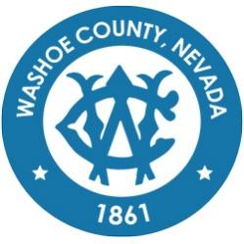
Washoe County
Local Emergency Planning Committee (LEPC)
Grants and Finance Committee
DRAFT of Minutes
July 21, 2021, 11:00 A.M.
Regional Emergency Operations Center
5195 Spectrum Boulevard, Reno, Nevada

1. CALL TO ORDER/ DETERMINATION OF QUORUM (Non-action item)
Vice Chair Brian Taylor called the meeting to order at 11:10 a.m. A quorum was established:
PRESENT: Andy Ancho – RFD; Elizabeth Kunz – RPD; Kelly Echeverria – WCEM; Brian Taylor – REMSA; Tracy Moore – WCSD; Eric Millette – SFD; Dale Carnes - RTAA and Megan Sullivan - Secretary/Treasurer
ABSENT: Marc Bello – WCSO; Jim Reid – SFD; Jon McNamara – RFD; Shyanne Schull – WCRAS; Ian Dasmann – TMWA; and Jim Nelligan – NLTFPD
Also present: Michael Large

2. PUBLIC COMMENT –
There was no public comment.

3. APPROVAL OF May 20, 2021 GRANTS AND FINANCE COMMITTEE MEETING MINUTES [FOR POSSIBLE ACTION] – Brain Taylor, Vice Chairperson

It was moved by Andy Ancho, seconded by Kelly Echeverria to approve the minutes as written.
There was no public comment.
The motion passed unanimously.

4. REVIEW OF CURRENT LEPC GRANTS AND FINANCES – Status of active grants (FY 21 Operations, Planning, Training, and Equipment (OPTE), and FY 21 United We Stand). Status of submitted applications FY 22 Operations, Planning, Training, and Equipment (OPTE), FY 22 United We Stand (UWS), and FY 21 Hazardous Materials Emergency Preparedness (HMEP) Mid‐Cycle. – Megan Sullivan, LEPC Secretary/Treasurer

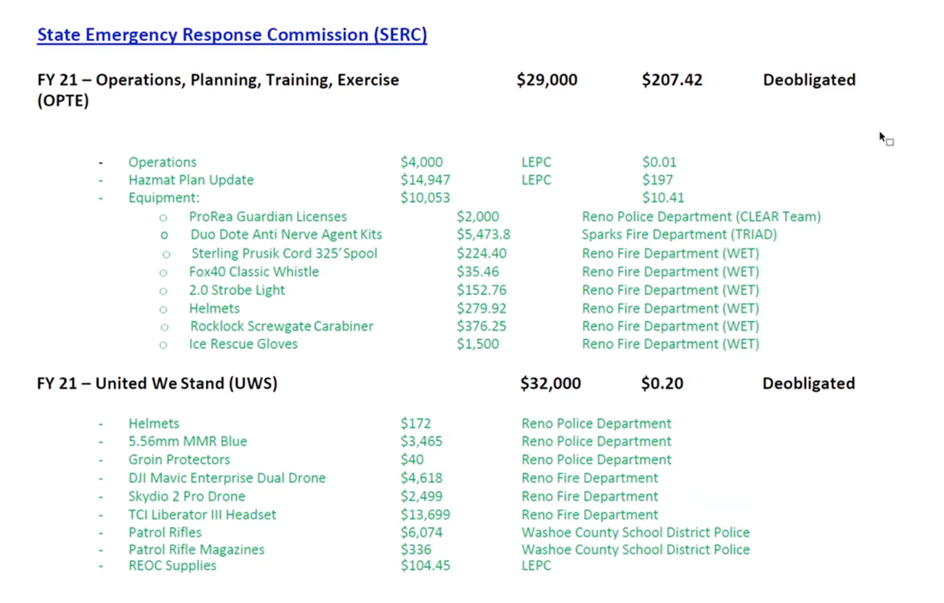
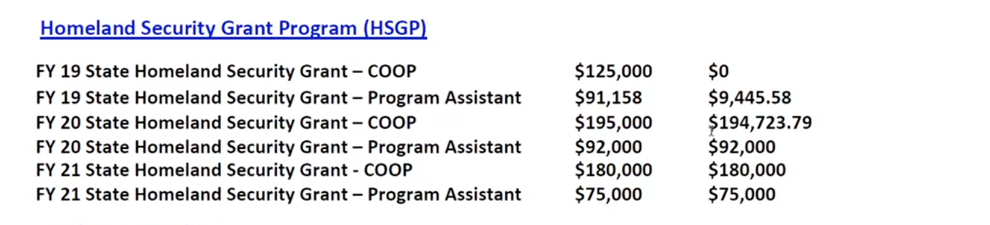
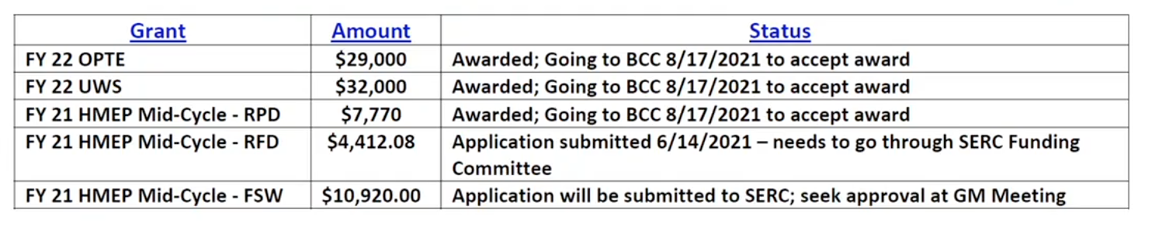
Megan explained that 56 people would like to attend the FSW conference.

Brain Taylor asked when funds will be available from the grants that have been accepted. Kelly Echeverria clarified that approvals are signed usually the same day. When funds are distributed exactly is unknown.
5. COMMITTEE MEMBER AND STAFF ANNOUNCEMENTS, REQUESTS FOR INFORMATION AND SELECTION OF TOPICS FOR FUTURE AGENDAS. No discussion among Committee members will take place on this item.
There was no comment.

6. PUBLIC COMMENT –
There was no public comment.

7. Brain Taylor adjourned meeting at 11:18am.

