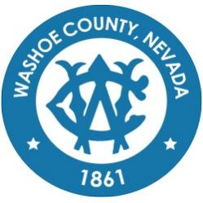
Washoe County
Local Emergency Planning Committee (LEPC)
General Membership Meeting
DRAFT of Minutes
June 17, 2021, 10:00 A.M.
Regional Emergency Operations Center
5195 Spectrum Boulevard, Reno, Nevada

1. CALL TO ORDER/ DETERMINATION OF QUORUM (Non-action item)
Brian Taylor called the meeting to order at 10:01 a.m. A quorum was established:
PRESENT: Elizabeth Kunz – RPD; Ryan Connelly - RPD; Eric Millette – SFD; Kelly Echeverria – WCEM; Brian Taylor – REMSA; Shyanne Schull – WCRAS; Ian Dasmann – TMWA; Roy Anderson – WCSD; Michael Perry - WCSD; Shawn McEvers - SFD; Jim Nelligan – NLTFPD; Dale Carnes - RTAA; Michelle Bays - DA; Jessica Adams - WCMS; Julia Ratti - SL; Sabrina Brasuell - IHCC; Brittany Nevin - VAH; Rob Reeder - RTC; Stanton Tang - KOLOTV; Wade Barnett - KOLOTV; Scott Alquist - TMCC; Ben Davis - TMCC; Elizabeth Breedon - NVE; and Stephanie Rennick - NVE
ABSENT: Andy Ancho – RFD; Tracy Moore – WCSD; Joe Kamman – TMFPD; Chris Rowe - SPD; Marc Bello – WCSO; Bill Harvey - WCSO; Eric James - UNRPD; Chris Jones - SFD; Jim Kindness - SFD; Ryan Sommers - NLTFPD; Russel Barnum - NLTFPD; Ryan Rizzuto - TMFPD; Charles Moore - TMFPD; Alex Kukulus - TMFPD; Chris Hicks - DA; John Gurriere - DA; Quinn Korbulic - WCTS; Chris Long - WCTS; Tammy Wines-Jennings - WCRAS; Paul Burton - REMSA; Todd Kerfoot - REMSA; Tammy Oliver - IHCC; Dennis Nolan - IHCC; Jessie Latchaw - IHCC; Kent Choma - NNMC; Mechelle Arenque - VAH; Angela Reich - RTC; Amanda Windes - UNR; Spencer Lewis - UNR; Cody Shaddle - RPSD; Rebecca Knapp - RPSD; Dominica Yturbide - RPSD; Dave Hunkup - RSIC; Daniel Thayer - RSIC; Nida Harjo - RSIC; Lance Chantler - RSIC; Don Pelt - PLPT; Jonathan Prichard - PLPT; and David Paulon - PLPT
Also present: Carol Black

2. PUBLIC COMMENT –
Carol Black from Incline Village spoke about the need for emergency evacuation planning in and around Incline Village and Crystal Bay. She expressed concern about the impact of development projects on Route 28, near CalNeva, and other locations in the area on evacuation routes. She also drew attention to the TTD plans with TRPA to create a transit hub which will only increase vehicle congestion in the Crystal Bay and Incline Village area, making evacuation routes unsafe. She requested a review of the evacuation plan in this area.
Kelly Echeverria explained that the WCEM in connection with California departments are reviewing and updating emergency response planning for the Tahoe Basin as a whole in response to some of the issues mentioned in Carol’s comment. A Washoe County review of emergency procedures will be completed first, but next year a basin-wide response should be available.
3. APPROVAL OF APRIL 15, 2021 GENERAL MEMBERSHIP MINUTES – (FOR POSSIBLE ACTION) –
Ryan Connelly noted the need to remove former RPD representatives from the role list.

It was moved by Ryan Connelly, seconded by Scott Alquist to approve the minutes as written.
There was no public comment.
The motion passed unanimously.
4. APPROVAL OF SUBMITTED APPLICATIONS FOR FISCAL YEAR (FY) 22 – (FOR POSSIBLE ACTION) – Submitted applications include FY 22 Operations, Planning, Training, and Equipment (OPTE) Grant for $29,000, FY 22, United We Stand (UWS) Grant for $32,000, FY 22 Hazardous Materials Emergency Preparedness (HMEP) Grant for $7,770, and FY 22 HMEP Grant for $4,412.08. –
FY 22 Operations, Planning, Training, and Equipment (OPTE) Grant for $29,000:
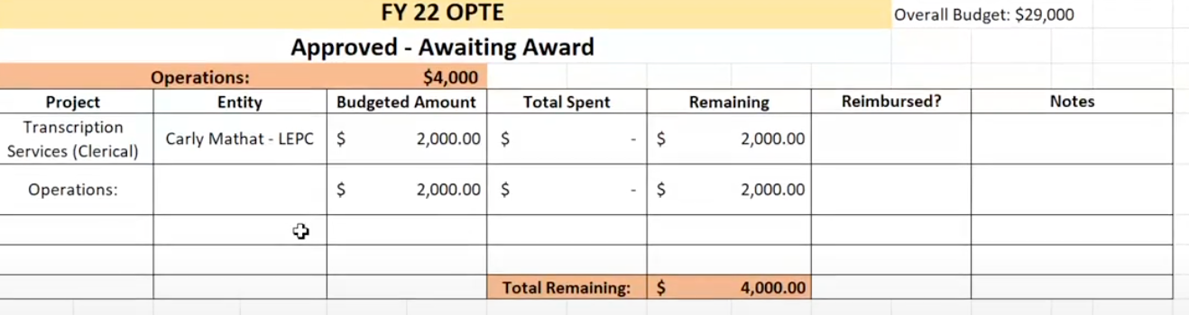
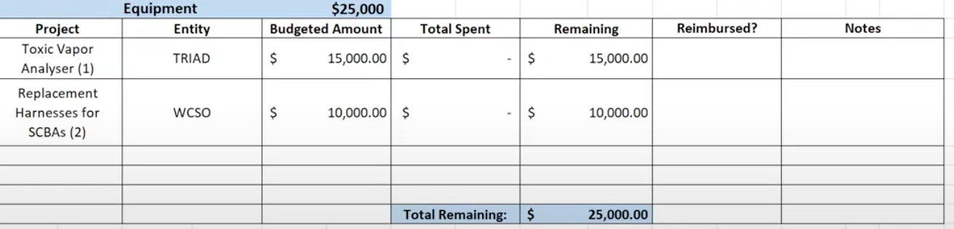
The FY 22 OPTE grant totalling $29,000 was approved by the GF as well as SERC but still needs approval from general membership.
United We Stand (UWS) Grant for $32,000:
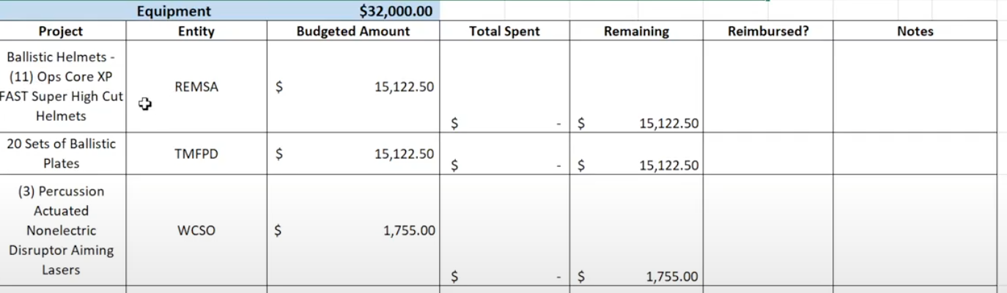
The UWS grant for $32,000 was approved by SERC and is awaiting approval from general membership.
FY 21 HMEP Mid-Cycle - RPD:
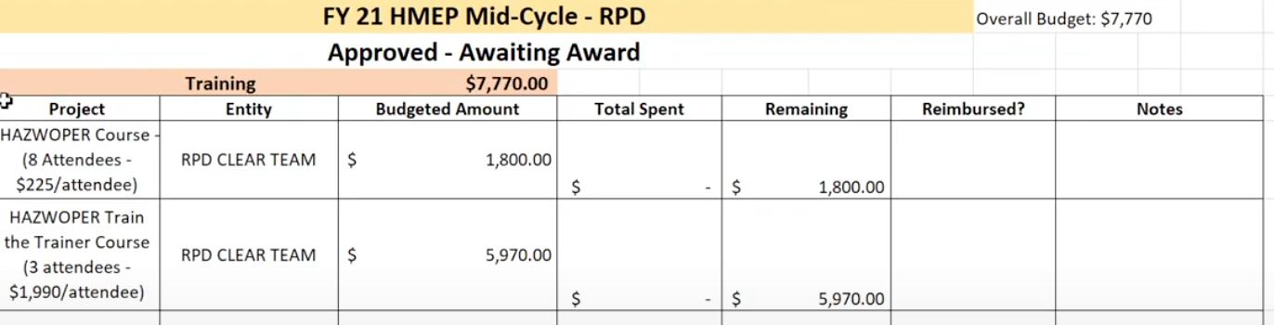
The FY 21 HMEP Mid-Cycle grant for $7,700 was approved by GF and SERC and is awaiting approval by general membership.
FY 21 HMEP Mid-Cycle - RFD:
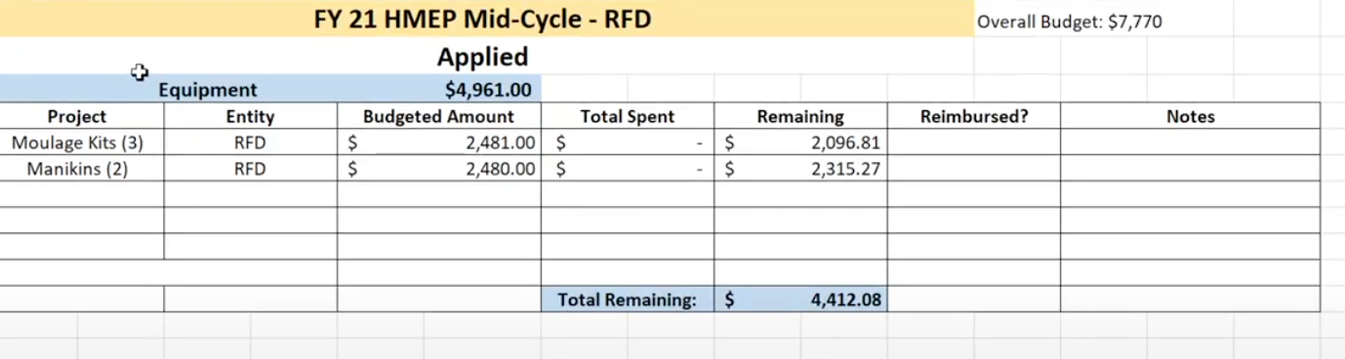
The FY 21 HMEP Mid-Cycle grant for $4,412.08 has not yet gone to GF however general membership can still discuss and approve this grant.

It was moved by Eric Millette, seconded by Dale Carnes to grant final approval to the FY 22 Operations, Planning, Training, and Equipment (OPTE) Grant for $29,000, FY 22 United We Stand (UWS) Grant for $32,000, and the FY 22 Hazardous Materials Emergency Preparedness (HMEP) Grant for $7,770, as well as preliminary approval to the FY 22 HMEP Grant for $4,412.08.
There was no public comment.
The motion passed unanimously.
5. SECRETARY/TREASURERS REPORT – Approval of FY 22 Operations, Planning, Training, and Equipment (OPTE), FY 22 United We Stand (UWS), and FY 21 Hazardous Materials Emergency Preparedness (HMEP) Mid-Cycle Grants. Information on existing and upcoming LEPC grants, member information, and trainings. – Kelly Echeverria - WCEM
The FY 21 OPTE grant spent all but $207.42 which will be deobligated.
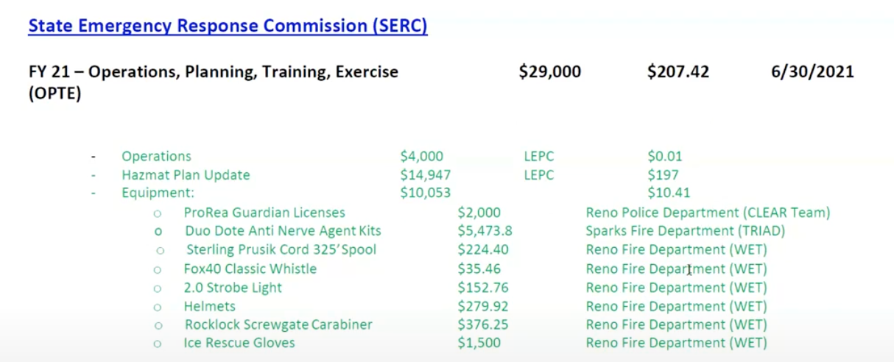
The FY 21 UWS grant spent all but $.20 which will be deobligated.
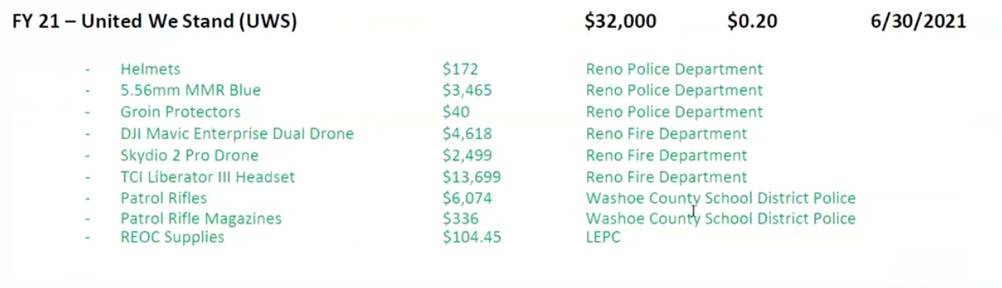
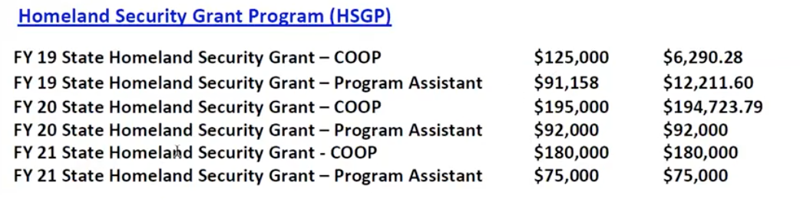
The FY 19 State - COOP funds were approved to be consolidated. The FY 19 State - Program Assistant funds are still in use to pay salary, and will continue until they are depleted before moving on to the FY 20 for Program Assistant grant. FY 20 State - COOP funds have been used for website updates. FY 21 grants are still in the planning process. As of July 1st, SERC will begin the process of sending awards for approved applications to LEPCs.
There was no public comment.
6. PRESENTATION ON MEDICAL COUNTERMEASURES PLAN – Discussion on the current medical countermeasures plan and the strategic national stockpile. –
Stephen Shipman requested to push this item to the next meeting on August 19th. Brian Taylor accepted this request.
There was no public comment.
7. PRESENTATION ON THE CHEMICAL BIOLOGICAL, RADIOLOGICAL, NUCLEAR, AND HIGH YIELD EXPLOSIVES (CBRNE) PLAN – Discussion on the current Washoe County Health District’s CBRNE Plan, an annex to WCHD Emergency Operations Plan, that encompasses the Bio-Detection System Response Plan, Pharmacy Cache Plan, CHEMPACK Plan, and Community Reception Center Operations Manual. – Stephen Shipman, Washoe County Health District
Stephen Shipman requested to push this item to the next meeting on August 19th. Brian Taylor accepted this request.
8. PRESENTATION ON NV ENERGY PUBLIC SAFETY OUTAGE MANAGEMENT (PSOM) – Discussion on NV Energy’s efforts to reduce the risk of wildfires within extreme fire-risk areas, as well as responding to those wildfire incidents. – Liz Breeden & Mark Regan, NV Energy
Liz Breeden presented on the Public Safety Outage Management programs on behalf of NVEnergy.
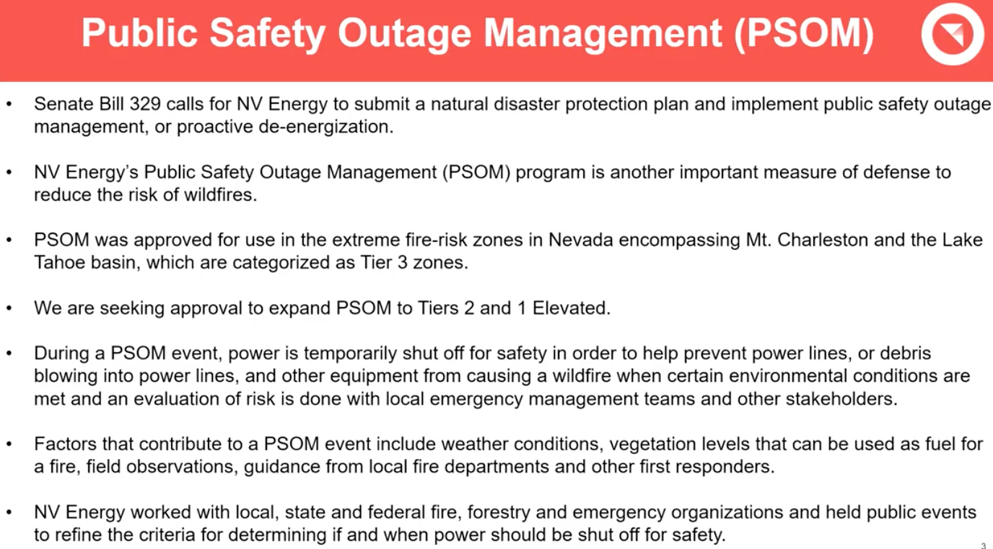
Liz Breeden explained that NVEnergy mitigation efforts have been in progress since 2019. Some of these efforts include increased cameras, grid hardening and fire mesh wrap to protect electrical poles. They are also clearing vegetation around lines and pole grubbing. All mitigation efforts are not only accounting for wildfires but year-round weather events.
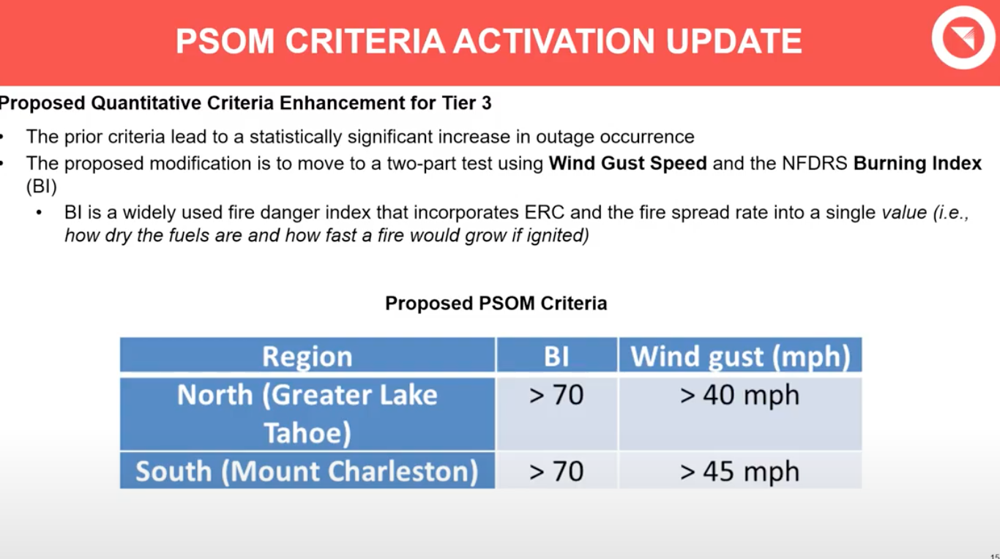
NVEnergy is proposing a change in the criteria for Tier 3 based on Wind Gust Speed and Burning Index as the previous index has proven less accurate.
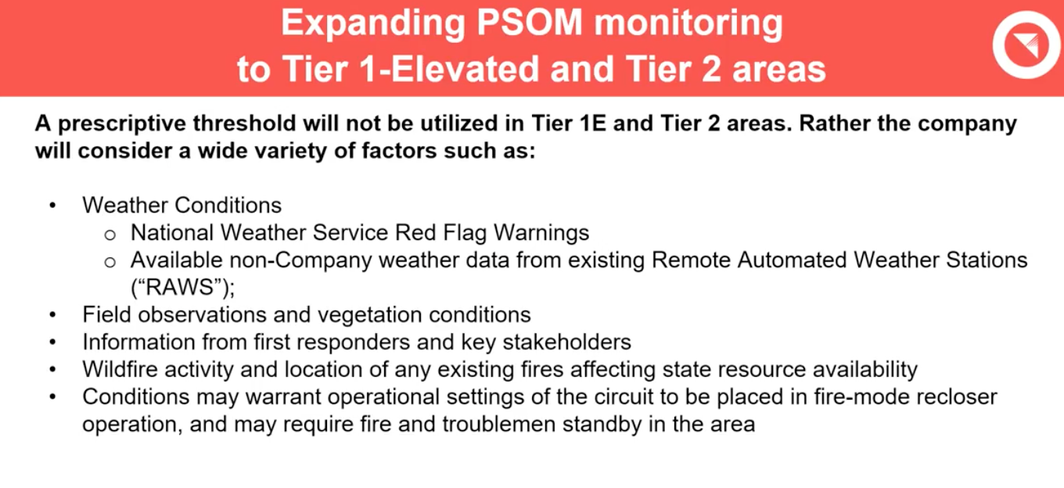
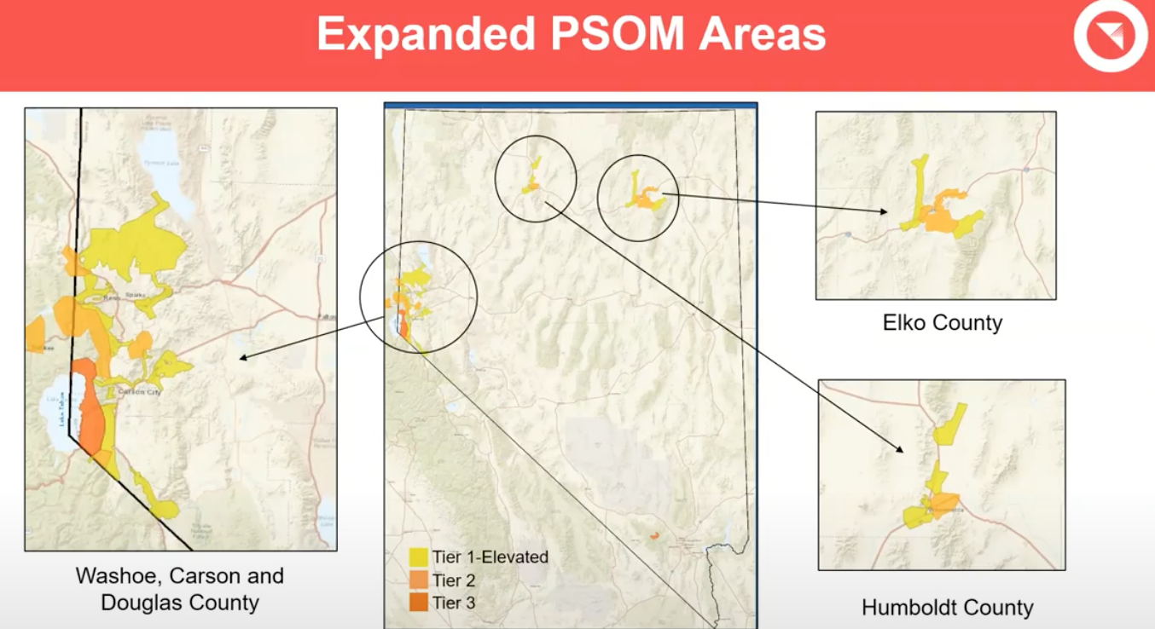
Over 200 new circuits have been added to new tiered areas as well as cut-outs which allow for more-targeted energy shut-offs that affect less customers.
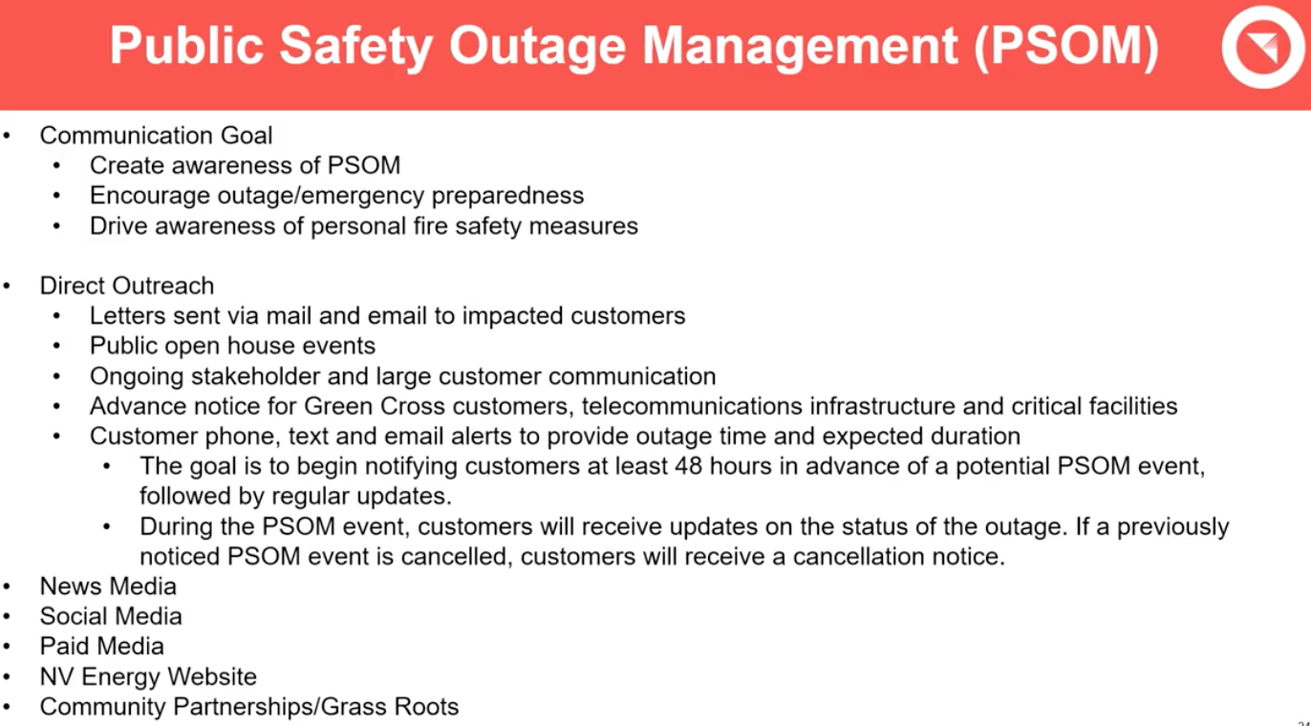
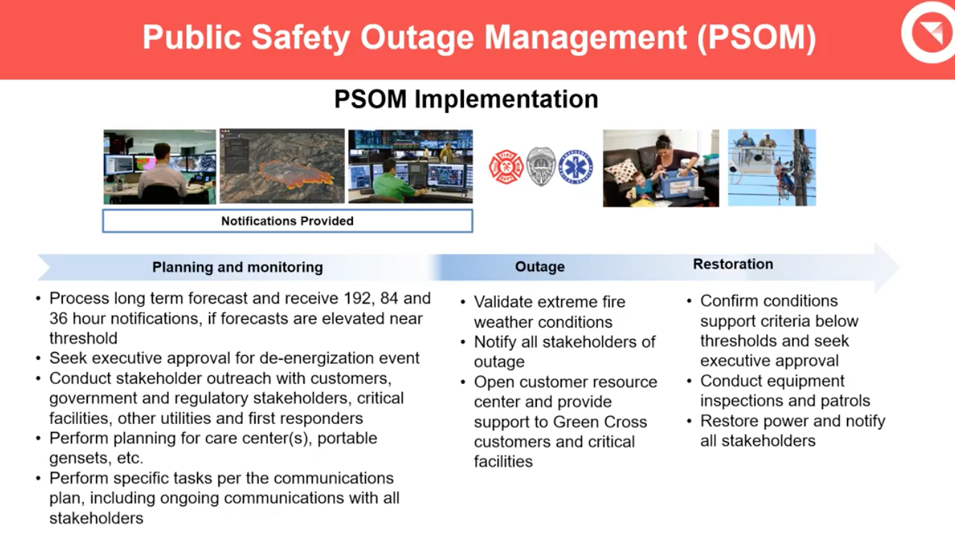
NVEnergy will be using Customer Resource Centers during PSOM events to provide communities with information, charging stations, water and other possible needs.
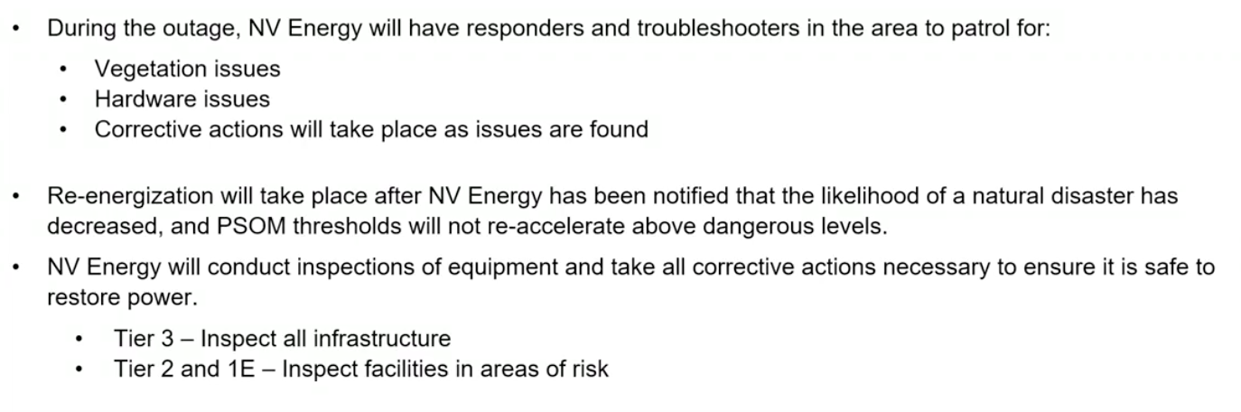
Liz Breeden explained that there will be opportunities in the future for community members to ask questions about PSOM.
9. UPDATE ON REGIONAL EMERGENCY MANAGEMENT EVENTS - A briefing of regional meetings, events, trainings and exercises. –
Kelly Echeverria said that last weekend Pyramid Lake Paiute Tribe had an issue with their water. WCEM worked with various other entities to respond with pallets of water and potable water tanks to support the community until issues with their well can be solved. There was also a fire on 395 which led to evacuations of surrounding areas. WCEM sent out be-prepared-to-evacuate notices to a wider area in response. Fuji park was opened to shelter larger animals in potential danger. There were also two table-tops, one for the Reno Air Races as well as a cyber security exercise.
10. UPDATE ON THE RADIOLOGICAL TASK FORCE - A briefing on current radiological issues within the region -
Scott Alquist explained that with COVID, there have been very few cases in the area. He also noted that throughout the pandemic there have only been a total of nineteen cases and the past few weeks have had zero positivity ratings.
11. UPDATE OF WASHOE COUNTY CITIZEN CORPS - A briefing on events and activities supported by the Washoe County Citizen Corps including, but not limited to, Community Emergency Response Teams (CERT) –
Michael Perry spoke on behalf of Joe Oleciregui who had a last minute time conflict. He said that the team has been very active since January.
12. UPDATE ON STATE EMERGENCY RESPONSE COMMISSION – A briefing on grants status and State Emergency Response Commission (SERC) happenings –
Christina Wilson explained that the OPTE, UWS and almost all of the Mid-Cycle grants have been approved. Awards for approved grants will be processed soon. As of July 1st, SERC will be doing the state’s Toxic Release Inventory Invoicing for all state facilities. SERC will be participating in National Night Out on August 3rd at Mills Park. Fire Shows West will be holding in-person and online classes and is working on releasing class lists. Christina also clarified that SERC has also updated some of the policies and bi-laws to maintain regulatory compliance.
13. TRAINING REVIEW – Briefing on trainings that have occurred in the past 2 months and requests for future trainings. Upcoming Trainings. –
Eric Millette said that there is a TRIAD HAZMAT exercise at the Stead Airbase coming up. Brian Taylor commented that the table-top for the Reno Air Races was well-attended and successful.
14. LEPC CHAIRMAN/BOARD MEMBER ANNOUNCEMENTS/ITEMS AND SELECTION OF TOPICS FOR FUTURE MEETINGS -
No announcements or items were offered
15. PUBLIC COMMENT –
Diane Becker expressed concern about the 48 hour notice of power outages as she feels it is not enough warning to prepare efficiently. She requested that NVEnergy consider their ability to give more notice to community members. Diane asked that WCEM make a request to NVEnergy on this topic on behalf of the community.
16. Brian Taylor adjourned meeting at 11:18am.

