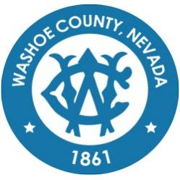
Washoe County
Local Emergency Planning Committee (LEPC)
Grants and Finance Committee
DRAFT of Minutes
May 20, 2021, 11:00 A.M.
Regional Emergency Operations Center
5195 Spectrum Boulevard, Reno, Nevada

1. CALL TO ORDER/ DETERMINATION OF QUORUM (Non-action item)
Chair Millette called the meeting to order at 11:03 a.m. A quorum was established:
PRESENT: Andy Ancho – RFD; Elizabeth Kunz – RPD; Eric Millette – SFD; Kelly Echeverria –WCEM; Brian Taylor – REMSA; Shyanne Schull – WCRAS; Jon McNamara – RFD; Ian Dasmann – TMWA; Roy Anderson – WCSD; and Megan Sullivan - Secretary/Treasurer
ABSENT: Tracy Moore – WCSD; Jim Reid – SFD; Jack Byrom – TMWA; Christina Conti – WCHD; Bruce Hicks – NLTFPD; Jim Nelligan – NLTFPD; Kelly McGlynn – TMWA; Joe Kamman – TMFPD; Pete Krall – SPD; and Tom Nelson – RTAA; Paul Pertaker – RFD; Marc Bello – WCSO
Also present: Legal – Nathan Edwards

2. PUBLIC COMMENT –
There was no public comment.

3. APPROVAL OF April 13, 2021 GRANTS AND FINANCE COMMITTEE MEETING MINUTES [FOR POSSIBLE ACTION] –

It was moved by Brian Taylor, seconded by Kelly Echeverria to approve the minutes as written.
There was no public comment.
The motion passed unanimously.

4. UPDATE ON SUBMITTED APPLICATIONS – Discussion on the status of submitted grant applications: Fiscal Year (FY) 22 Operations, Planning, Training, and Equipment (OPTE), FY 22 United We Stand (UWS), and FY 21 Hazardous Materials Emergency Preparedness (HMEP) Mid‐Cycle. – Megan Sullivan, LEPC Secretary/Treasurer

Megan Sullivan clarified that the FY, OPTE, UWS, and HMEP grants have all been submitted. There were some changes made to the HMEP Mid-Cycle to account for allowable expenses that may not be permissible under HMEP. The Hazwoper Training and Hazwoper Train the Trainer application was submitted for $7,770. The application for moulage kits and manikins for Reno Fire Department is still in process as it was determined they were not covered by HMEP. The grant however can be submitted in multiple applications. The SERC Funding Committee Meeting on May 26, 2021 at 1pm will determine if the current applications have been approved. Brian Taylor clarified that Andy Ancho is working on the letter for HMEP. Brain also stated that cynokits are under consideration for their safety and a determination on their further use will be made in the near future. Eric Millette clarified seeking funding for the kits will not be aggressive while the investigation of the kits is in process.

5. REVIEW OF CURRENT LEPC GRANTS AND FINANCES – Status of active grants (FY 21 Operations, Planning, Training, and Equipment (OPTE), and FY 21 United We Stand). – Megan Sullivan, LEPC Secretary/Treasurer

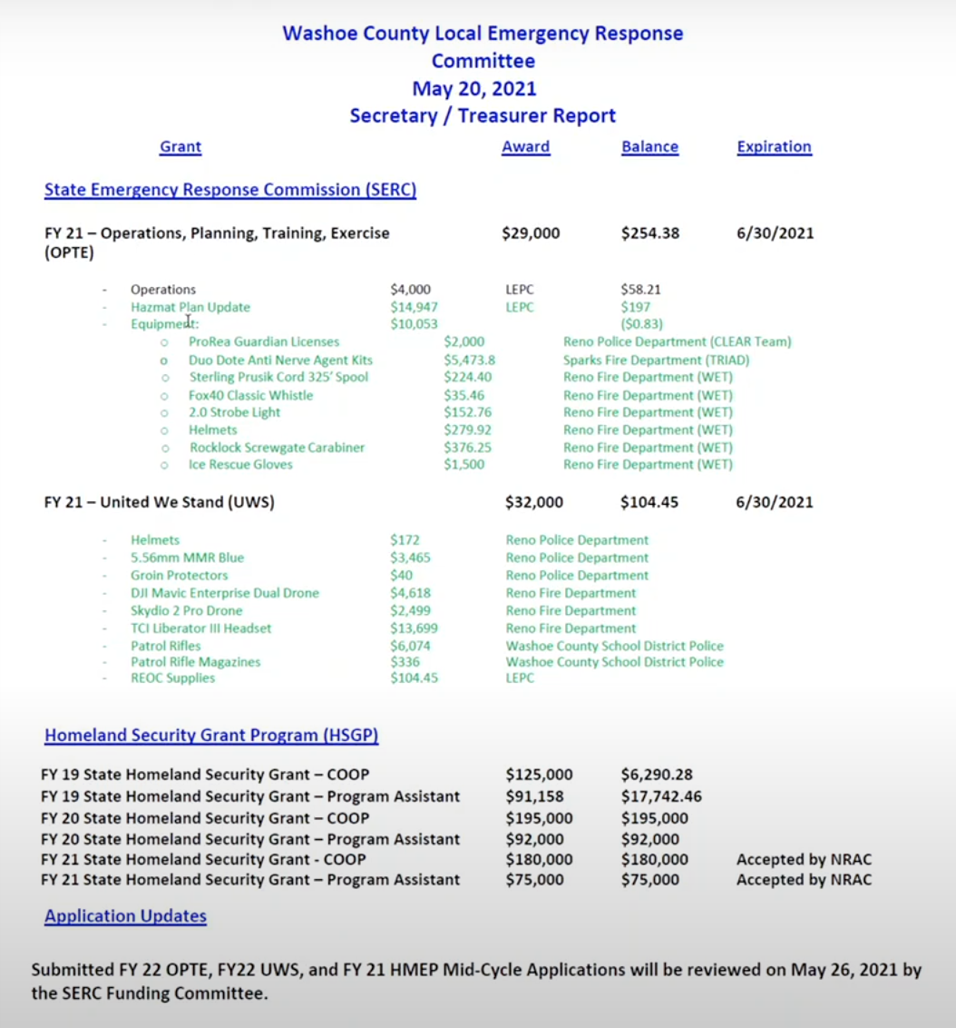
Megan Sullivan reviewed the remaining balances for each grant as shown in the figure above. She noted that she will be consolidating remaining expenses for OPTE into operations so that remaining funds can be utilized before the performance period ends. All UWS supplies have been ordered except REOC supplies.

6. COMMITTEE MEMBER AND STAFF ANNOUNCEMENTS, REQUESTS FOR INFORMATION AND SELECTION OF TOPICS FOR FUTURE AGENDAS -

Eric Millette asked for clarification why the FY 20 COOP funds remain so high. Kelly Echeverria noted that this is because the purchasing department has not closed out RFTs for its vendors but is working daily to do so.

7. PUBLIC COMMENT –
There was no public comment.

8. Eric Millette adjourned meeting at 11:14am.

