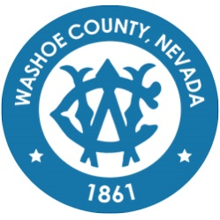
Washoe County
Local Emergency Planning Committee (LEPC)
Minutes

April 15, 2021 10:00 A.M.
Regional Emergency Operations Center
5195 Spectrum Boulevard, Reno, Nevada

1. CALL TO ORDER/DETERMINATION OF QUORUM [Non-action item]
Chair Millette called the meeting to order at 10:06 a.m. A quorum was established.

PRESENT: Elizabeth Kunz – RPD; Ryan Connelly – RPD; Marc Bello – WCSD; Tracy Moore – WCSD; Roy Anderson – WCSD; Andy Ancho - RFD; Shawn McEvers – SFD; Eric Millette – SFD; Joe Kammann – TMFPD; Ryan Rizzuto – TMFPD; Jim Nelligan – NLTFPD; Charles Moore – TMFPD; Kelly Echeverria – WCEM; Jessica Adams – WCEM; Brian Taylor – REMSA; Sabrina Brasuell – IHCC; Dennis Nolan – IHCC; Brittany Nevin – IHCC; Rob Reeder – RTC; Dale Carnes – RTAA; Stanton Tang – KOLO-TV; Amanda Windes – UNR; Ben Davis – TMCC; Dave Hunkup – RS Indian Colony; Don Pelt – Pyramid Lake Pauite Tribe; Jonathan Prichard - Pyramid Lake Pauite Tribe; David Paulon – Pyramid Lake Pauite Tribe; and Elizabeth Breeden – NV Energy
ABSENT: Michael Perry – WCSD; Scott Tracy – SPD; Jenna Wilch – UNRPD; Mark Jongsma – RTAA; Eric James – UNRPD; Debbie Penrod – UNRPD; Julie Hunter – Health Dist; Michelle Bays – Dist. Attorney; Sean Garlock – RPD; Christina Wilson - SERC; Zach Nammara – TMFPD; Sam Hicks – TMFPD; Chris Long – WC Tech Services; Rob Larson – RPD; Chris Rowe – SPD; Todd Kerfoot – REMSA; Dominique LeBlanc – WCSD; Dick Nachtsheim – RFD; Jim Reid – RFD; Jason Elorza – RFD; Ryan Sommers – NLTFPD; Bryan Calder – NLTFPD; James English – Health Dist; Shyanne Schull – WC Animal Services; Tom Nelson – RTAA; Charles Albee – Health Dist; Teresa Long – Health Dist; Steve Leighton – Triad; Chris Hicks – District Attorney; John Gurriere – Dist Attorney; Rebecca Knapp – RPSD; Tammy Wines-Jennings – WC Animal Services; Paul Burton – REMSA; Tammy Oliver – IHCC; Margo Baxter – IHCC; Mechelle Arenque – VA Hospital; Angela Reich – RTC; Wade Barnett – KOLO-TV; Ed Pearce - KOLO-TV; Scott Alquist – TMCC; Spencer Lewis – UNR; Nida Harjo – RS Indian Colony; Rene Tyler – NV Energy; Kelly McGlynn – TMWA; Lance Chantler – RS Indian Colony; Quinn Korbulic – WC Tech Services; Sean Applegate – NMMC; Daniel Thayer – RS Indian Colony; Dena Avansino – RPSD; Jack Byrom – TMWA; Ian Dasmann – TMWA; and Dominica Yturbide – RPSD.
Also present: Legal, Nate Edwards
2. PUBLIC COMMENT –

There was no public comment.

3. APPROVAL OF DECEMBER 17, 2020 GENERAL MEMBERSHIP MINUTES – FOR POSSIBLE ACTION –

It was moved by Brian Taylor, seconded by Marc Bello to approve the minutes as written.

Dave Hunkup noted a misspell.
The motion passed unanimously.
4. SECRETARY TREASURER SECRETARY/TREASURERS REPORT – INFORMATION ON EXISTING AND UPCOMING LEPC GRANTS, MEMBER INFORMATION, AND TRAININGS. –

Megan Sullivan presented on the following:

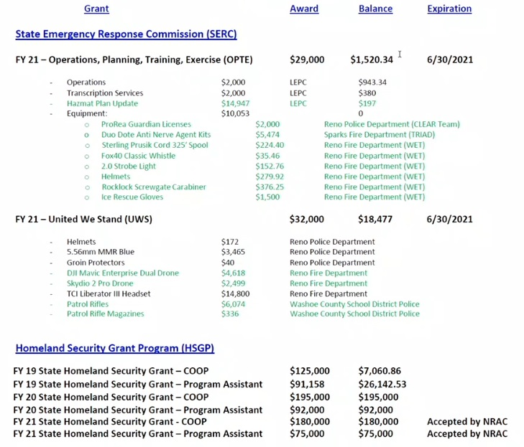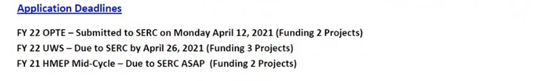
Chairman Millette noted the approval for UWS and HMEP wasn’t agendized properly; therefore, they cannot be voted on for approval today. Megan Sullivan noted OPTE grant application amounts were broken into $15,000 for TRIAD, $10,000 for WCSO and $4,000 for operations. Megan Sullivan further clarified UWS application amounts were broken into $15,122.50 to REMSA, $15,122.50 to TMFPD, $1,755 to WCSO. Megan Sullivan also noted the HMEP application amounts were broken into $7,770 to RPD and $19,379.60 to RFD.
Chairman Millette noted TRIAD received funding from COOP grant.

5. UPDATE ON REGIONAL EMERGENCY MANAGEMENT EVENTS - A BRIEFING OF REGIONAL MEETINGS, EVENTS, TRAININGS AND EXERCISES –

Kelly Echeverria noted ongoing support for vaccinations throughout the community. Kelly Echeverria also noted PPE available for agencies in need. Kelly Echeverria noted Human Services Agency is getting trained on bomb identifications. Chairman Millette noted the training calendar will hopefully fill more with in person events as the state reopens.

6. UPDATE ON THE RADIOLOGICAL TASK FORCE - A BRIEFING ON CURRENT RADIOLOGICAL ISSUES WITHIN THE REGION –

Chairman Millette noted radiological products continue to be transported through the area.

7. UPDATE OF WASHOE COUNTY CITIZEN CORPS - A BRIEFING ON EVENTS AND ACTIVITIES SUPPORTED BY THE WASHOE COUNTY CITIZEN CORPS INCLUDING, BUT NOT LIMITED TO, COMMUNITY EMERGENCY RESPONSE TEAMS (CERT) –

Chairman Millette noted Citizen Corp has been active with volunteer hours toward vaccinations. Kelly Echeverria noted CERT, Animal Services, and WCEM all provided vaccination tents throughout region. Sean McEvers noted Citizen Corp group active throughout Sparks.

8. UPDATE ON STATE EMERGENCY RESPONSE COMMISSION – A BRIEFING ON GRANTS STATUS AND STATE EMERGENCY RESPONSE COMMISSION (SERC) HAPPENINGS –

Christina Wilson noted OPTE grant application deadline passed and they are working on it. Christina Wilson noted the UWS grant submission period is open until April 26th; also, the fiscal year 21 for OPTE/UWS will close June 30th.

9. TRAINING REVIEW – BRIEFING ON TRAININGS THAT HAVE OCCURRED IN THE PAST 2 MONTHS AND REQUESTS FOR FUTURE TRAININGS. UPCOMING TRAININGS. –

Chairman Millette noted local fire agencies are training for wildfire season. He also noted local law enforcement has also been training.

10. LEPC MEMBER PRESENTATION (ONGOING, BASED ON DEPARTMENTAL AVAILABILITY) – LEPC MEMBER DISCUSSES ANY PURCHASES MADE WITH GRANT FUNDS, PREVIOUS OR CURRENT, THROUGH LEPC. –

Tracy Moore presented on items received from UWS funding including patrol rifles, breaching kits, bleeding control kits, and ballistic blankets.

Christina Wilson suggested a compilation of item acquired through grants be provided to CERT at the end of the year.

11. LEPC CHAIRMAN/BOARD MEMBER ANNOUNCEMENTS/ITEMS AND SELECTION OF TOPICS FOR FUTURE MEETINGS - NO DISCUSSION AMONG COMMITTEE MEMBERS WILL TAKE PLACE ON THIS ITEM. THE NEXT REGULAR MEETING IS SCHEDULED AT 10:00 A.M. JUNE 17, 2021.

There was no comment.

12. PUBLIC COMMENT –

There was no public comment.

13. Chairman Millette adjourned meeting at 10:49a.

