Washoe County
Local Emergency Planning Committee (LEPC)
Minutes

February 18, 2021 10:00 A.M.
Regional Emergency Operations Center
5195 Spectrum Boulevard, Reno, Nevada

1. CALL TO ORDER/DETERMINATION OF QUORUM [Non-action item]
Chair Moore called the meeting to order at 10:05 a.m. A quorum was established.

PRESENT: Elizabeth Kunz – RPD; Ryan Connelly – RPD; Marc Bello – WCSD; Tracy Moore – WCSD; Michael Perry – WCSD; Roy Anderson – WCSD; Andy Ancho - RFD; Shawn McEvers – SFD; Eric Millette – SFD; Joe Kammann – TMFPD; Ryan Rizzuto – TMFPD; Kelly Echeverria – WCEM; Brian Taylor – REMSA; Sabrina Brasuell – IHCC; Jessie Latchaw – IHCC; Brittany Nevin – IHCC; Rob Reeder – RTC; Stanton Tang – KOLO-TV; Amanda Windes – UNR; Ian Dasmann – TMWA; and Elizabeth Breeden – NV Energy;
ABSENT: Scott Tracy – SPD; Jim Nelligan – NLTFPD; Jenna Wilch – UNRPD; Mark Jongsma – RTAA; Eric James – UNRPD; Debbie Penrod – UNRPD; Julie Hunter – Health Dist; Charles Moore – TMFPD; Michelle Bays – Dist. Attorney; Sean Garlock – RPD; Christina Wilson - SERC; Zach Nammara – TMFPD; Sam Hicks – TMFPD; Jessica Adams – WCEM; Chris Long – WC Tech Services; Rob Larson – RPD; Chris Rowe – SPD; Todd Kerfoot – REMSA; Dominique LeBlanc – WCSD; Dick Nachtsheim – RFD; Jim Reid – RFD; Jason Elorza – RFD; Ryan Sommers – NLTFPD; Bryan Calder – NLTFPD; James English – Health Dist; Shyanne Schull – WC Animal Services; Tom Nelson – RTAA; Charles Albee – Health Dist; Teresa Long – Health Dist; Steve Leighton – Triad; Chris Hicks – District Attorney; John Gurriere – Dist Attorney; Rebecca Knapp – RPSD; Tammy Wines-Jennings – WC Animal Services; Paul Burton – REMSA; Tammy Oliver – IHCC; Margo Baxter – IHCC; Mechelle Arenque – VA Hospital; Angela Reich – RTC; Wade Barnett – KOLO-TV; Ed Pearce - KOLO-TV; Scott Alquist – TMCC; Ben Davis – TMCC; Spencer Lewis – UNR; Nida Harjo – RS Indian Colony; Jonathan Prichard - Pyramid Lake Paiute Tribe; David Paulon – Pyramid Lake Paiute Tribe; Rene Tyler – NV Energy; Kelly McGlynn – TMWA; Don Pelt – Pyramid Lake Paiute Tribe; Dave Hunkup – RS Indian Colony; Lance Chantler – RS Indian Colony; Quinn Korbulic – WC Tech Services; Sean Applegate – NMMC; Daniel Thayer – RS Indian Colony; Dena Avansino – RPSD; Jack Byrom – TMWA; and Dominica Yturbide – RPSD.
Also present: Legal, Nate Edwards
2. PUBLIC COMMENT –

Mike Algots with Union Pacific Railroad noted he is available for outreach assistance. Samantha Windes noted she is looking for EM professionals for a study.

3. APPROVAL OF DECEMBER 17, 2020 GENERAL MEMBERSHIP MINUTES – FOR POSSIBLE ACTION –

It was moved by Brian Taylor, seconded by Roy Anderson to approve the minutes as written.

There was no public comment.
The motion passed unanimously.
4. APPOINTMENT OF SECRETARY/TREASURER – FOR POSSIBLE ACTION – APPOINTMENT OF MEGAN SULLIVAN TO LEPC SECRETARY/TREASURER POSITION –

It was moved by Roy Anderson, seconded by Rob Reeder to approve Megan Sullivan as LEPC Secretary/Treasurer.

There was no public comment.
The motion passed unanimously.
5. SECRETARY TREASURER SECRETARY/TREASURERS REPORT – INFORMATION ON EXISTING AND UPCOMING LEPC GRANTS, MEMBER INFORMATION, AND TRAININGS.

Megan Sullivan reported on the following grant information:
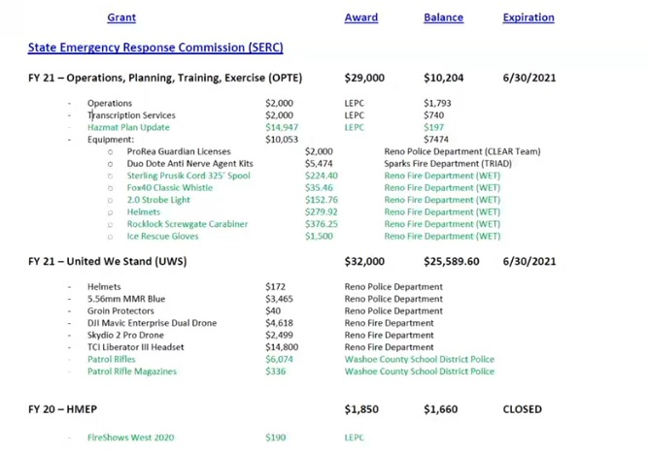
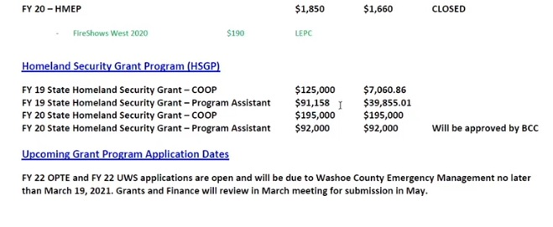
Kelly Echeverria noted the FY 22 UWV/OPTE grants are due no later than March 19th to be reviewed in the April Grants and Finance meeting. Kelly Echeverria also noted a mistake in when grants were available mid-cycle; those applications are still on file and to please touch base with Megan.

6. APPROVAL OF 2020 LEPC MEMBERSHIP FORM – FOR POSSIBLE ACTION -- APPROVAL OF THE NEVADA STATE EMERGENCY RESPONSE COMMISSION (SERC) MEMBERSHIP FORM COMPLETED AND SUBMITTED TO SERC. SERC IS A STATE ENTITY COMPRISED OF MEMBERS APPOINTED BY THE GOVERNOR AND REPRESENTING THE VARIOUS STATE AND LOCAL GOVERNMENT ORGANIZATIONS, PRIVATE INDUSTRY, AND THE GENERAL PUBLIC. SERC’S CHIEF FUNCTION IS TO PROTECT THE CITIZENS OF NEVADA FROM THE NEGATIVE EFFECTS OF HAZARDOUS MATERIALS. SERC ALSO SUPERVISES THE ACTIVITIES OF THE VARIOUS LEPCS AROUND THE STATE. THE SERC MEMBERSHIP FORM IS COMPLETED PERIODICALLY AND [EXPLAIN WHAT THE FORM DOES].

Kelly Echeverria noted while the membership list was noted on plan submitted to SERC, it was requested to complete an official membership form. Ryan Connelly noted he is the replacement for Rob Larson. Joe Kammann noted his name was misspelled.

It was moved by Brian Taylor, seconded by Liz Breeden to approve LEPC membership list.

There was no public comment.
The motion passed unanimously.
7. UPDATE ON REGIONAL EMERGENCY MANAGEMENT EVENTS - A BRIEFING OF REGIONAL MEETINGS, EVENTS, TRAININGS AND EXERCISES –

Kelly Echeverria noted vaccines are being rolled out and mentioned FEMA is also helping with vaccination efforts. Kelly Echeverria noted some DEM trainings. Kelly Echeverria noted the “Ham-Cram” training occurring.

8. UPDATE ON THE RADIOLOGICAL TASK FORCE - A BRIEFING ON CURRENT RADIOLOGICAL ISSUES WITHIN THE REGION -

Eric Millette noted biannual radiation detectors will be recalibrated soon.

9. UPDATE OF WASHOE COUNTY CITIZEN CORPS - A BRIEFING ON EVENTS AND ACTIVITIES SUPPORTED BY THE WASHOE COUNTY CITIZEN CORPS INCLUDING, BUT NOT LIMITED TO, COMMUNITY EMERGENCY RESPONSE TEAMS (CERT) –

There were no new updates.

10. UPDATE ON STATE EMERGENCY RESPONSE COMMISSION – A BRIEFING ON GRANTS STATUS AND SERC HAPPENINGS, INCLUDING BUT NOT LIMITED TO [STATE BRIEF SUMMARY OR LIST OF KNOWN ITEMS THAT WILL BE DISCUSSED]

There were no new updates.

11. TRAINING REVIEW – BRIEFING ON UPCOMING TRAININGS AND TRAININGS THAT HAVE OCCURRED IN THE PAST 2 MONTHS AND REQUESTS FOR INFORMATION ABOUT FUTURE TRAININGS. –

Kelly Echeverria noted Continuing Challenge is cancelled this year.

12. LEPC CHAIRMAN/BOARD MEMBER ANNOUNCEMENTS/ITEMS AND SELECTION OF TOPICS FOR FUTURE MEETINGS – THIS ITEM IS LIMITED TO ANNOUNCEMENTS AND PROPOSED ITEMS TO BE INCLUDED ON FUTURE AGENDAS. NO DISCUSSION AMONG COMMITTEE MEMBERS WILL TAKE PLACE ON THIS ITEM. THE NEXT REGULAR MEETING IS SCHEDULED AT 10:00 a.m. APRIL 15, 2021.

There were no comments.

13. PUBLIC COMMENT –

There was no public comment.

14. Eric Millette adjourned meeting at 10:40am.

