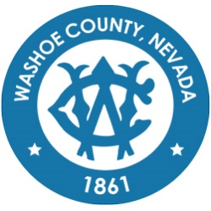
Washoe County
Local Emergency Planning Committee (LEPC)
Grants and Finance Committee
DRAFT of Minutes
March 25, 2021, 11:00 A.M.
Regional Emergency Operations Center
5195 Spectrum Boulevard, Reno, Nevada

1. CALL TO ORDER/ DETERMINATION OF QUORUM (Non-action item)
Chair Millette called the meeting to order at 11:06 a.m. A quorum was established:
PRESENT: Andy Ancho – RFD; Elizabeth Kunz – RPD; Eric Millette – SFD; Kelly Echeverria –WCEM; Brian Taylor – REMSA; Shyanne Schull – WCRAS; Kelly Echeverria – WCEM; Jon McNamara – RFD; Ian Dasmann – TMWA; Paul Pertaker – RFD; Marc Bello – WCSO; and Roy Anderson – WCSD
ABSENT: Tracy Moore – WCSD; Jim Reid – SFD; Jack Byrom – TMWA; Christina Conti – WCHD; Bruce Hicks – NLTFPD; Jim Nelligan – NLTFPD; Kelly McGlynn – TMWA; Joe Kamman – TMFPD; Pete Krall – SPD; and Tom Nelson – RTAA
Also present: Legal – Nathan Edwards

2. PUBLIC COMMENT –
There was no public comment.

3. APPROVAL OF SEPTEMBER 24, 2020 GRANTS AND FINANCE COMMITTEE MEETING MINUTES [FOR POSSIBLE ACTION]

It was moved by Brian Taylor, seconded by Andy Ancho to approve the minutes as written.
There was no public comment.
The motion passed unanimously.

4. FY 22 OPTE GRANT APPLICATION REVIEW AND APPROVAL [FOR POSSIBLE ACTION] – Prioritization and approval by the LEPC Grants and Finance Subcommittee on Operations, Planning, Training, and Equipment (OPTE) grant application submissions from LEPC disciplines. Approved applications will be submitted to the State Emergency Response Commission (SERC). This grant is offered and funded by SERC. The amount of grant funding requests available for distribution is no more than $25,000.
Chairman Millette noted that some of the amounts will exceed $25,000 as the previously planned funding source fell through.
Option #1 was presented by Eric Millette for TRIAD. Eric Millette noted the number of units requested has been reduced to 1.
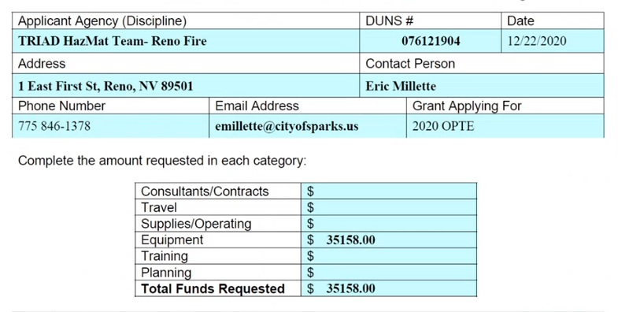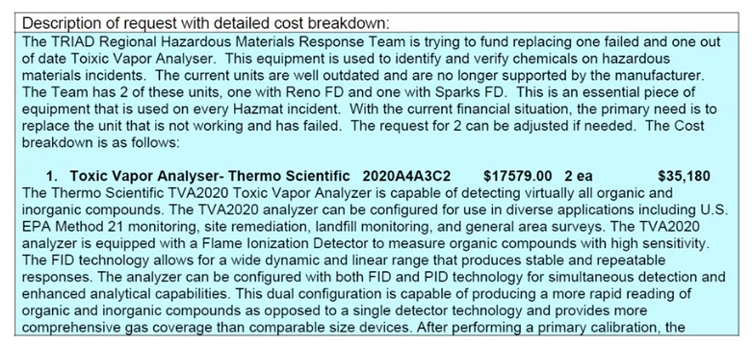
Option #2 was presented by Sergeant Bond for Clear Team.
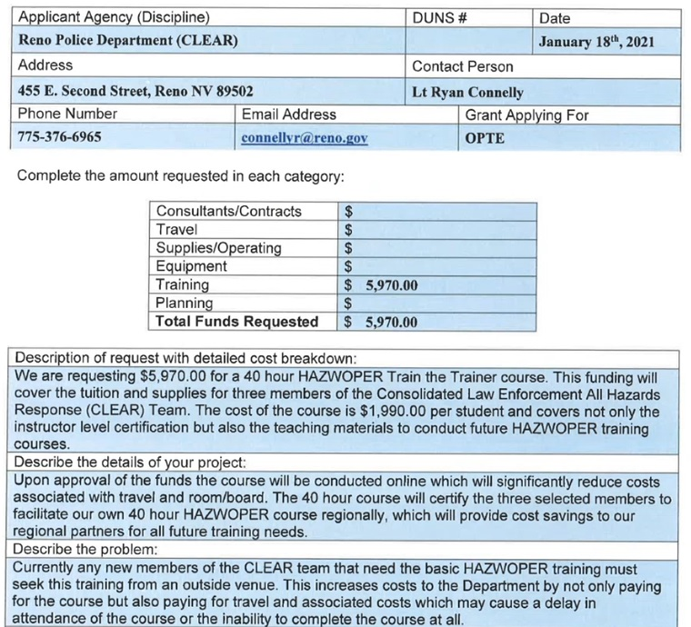
Megan advised that this option could possibly be absorbed by an HMEP grant. Elizabeth Kunz asked how long the turnaround for funding would be. Kelly clarified it would be between 30-120 days. Sergeant Bond noted if there is any funding within this grant left, they will accept it for this proposed application; otherwise, they will apply under the HMEP grant.

Option #3 was presented by Marc Bello for WCSO.
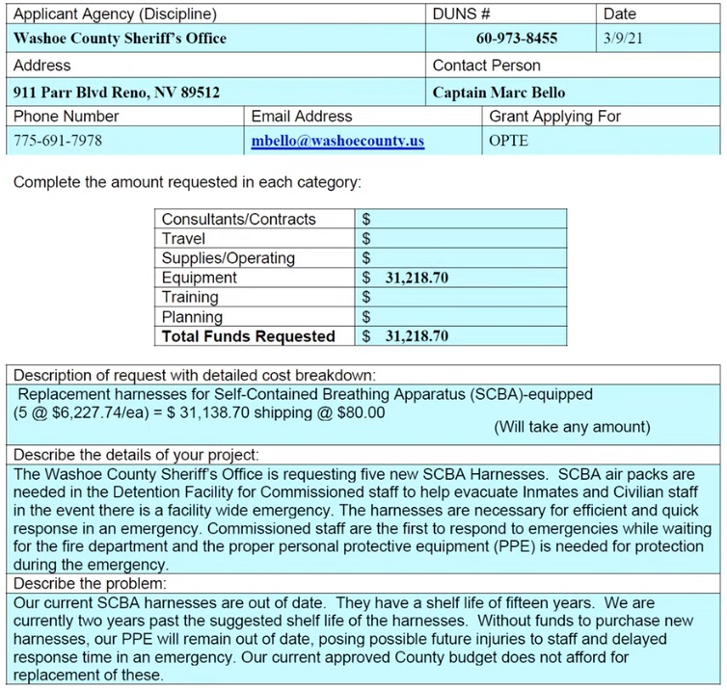
Marc Bello clarified any amount will be accepted to fall under the $25,000 cap. Eric Millette noted that the UWS grant is more directed toward terrorism which should be considered for future funding.

Option #4 was presented by Marc Bello for WCSO.
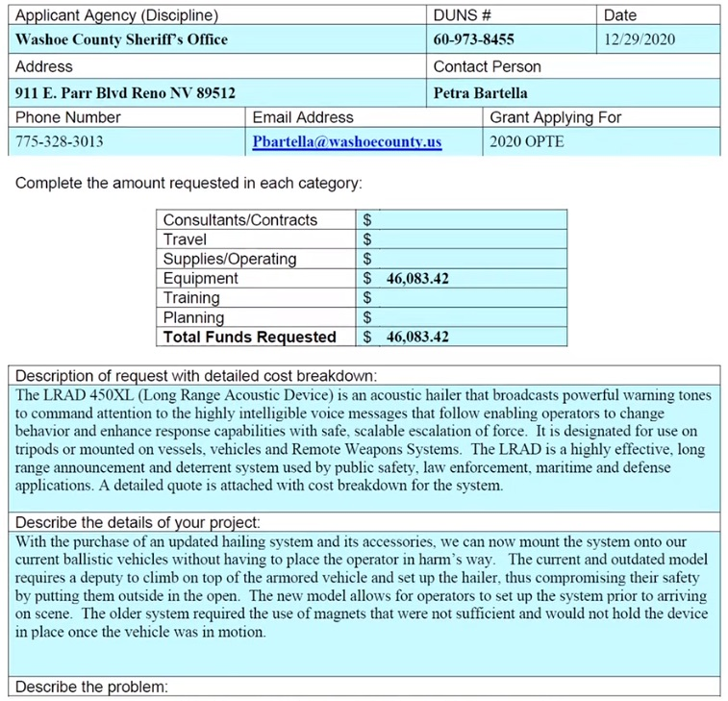
It was unclear if the amount could be reduced; however, it seemed the price was for a single kit so partial funding would not be effective.
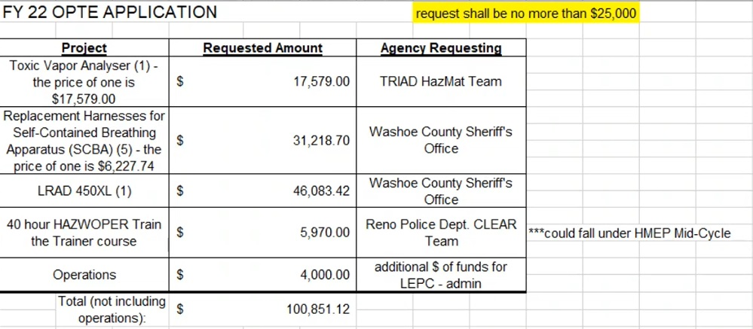
Elizabeth Kunz noted RPD will apply to HMEP grants it would be acceptable to consider other applications with a higher priority. Brian Taylor noted a representative for the LRAD for WCSD was not present so could not comment on if partial funding is available. Eric Millette noted TRIAD is now only seeking 1 Toxic Vapor Analyzer.

It was moved by Brian Taylor, seconded by Eric Millette to prioritize Opt.#1 TRIAD, Opt.# 3 WCSD (SCBA Pack), Opt.#4 WCSD (LRAD), and Opt.#2 RPD in that order.
There was no public comment.
The motion passed unanimously.
Eric Millette suggested TRIAD reducing requested amount to $15,000 and supplement the remaining amount of $2,579 in house and WCSO reduce requested number of SCBA packs to 2 for a total of $12,455 and supplement the remaining amount $2,455.48 in house as to utilize all available funds in grant. Marc Bello noted supplying additional $2,455.48 through WCSD is within their budget.

It was moved by Eric Millette, seconded by Elizabeth Kunz to fund TRIAD $15,000, and allow WCSO 2 SCBA packs for $10,000 and each agency supplementally fund residual costs of $2,579 for TRIAD and $2,455.48 for WCSD and to include $4,000 for operation costs included in grant.
There was no public comment.
The motion passed unanimously.

5. PLAN FOR 2021 GRANT APPLICATIONS – Review timeline laid out by the Nevada State Emergency Response Committee (SERC) for grant opportunities and funding applications that will be available in 2021.
Megan Sullivan noted FY22 OPTE application has been approved and UWS is open and due by April 9th to be reviewed on April 13th. Eric Millette noted the next Grants and Finance meeting is April 13th at 11am.
6. REVIEW OF CURRENT LEPC GRANTS AND FINANCES – Status of active grants (FY 21 OPTE and FY 21 United We Stand) The OPTE grant is described in item 4 above. The United We Stand (UWS) grant is to support preparedness to combat terrorism for LEPC.
Megan Sullivan present this report and noted all items in green have been procured.
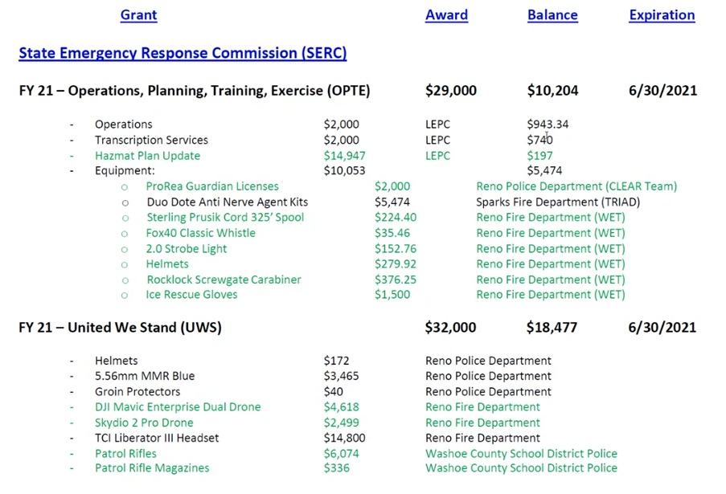
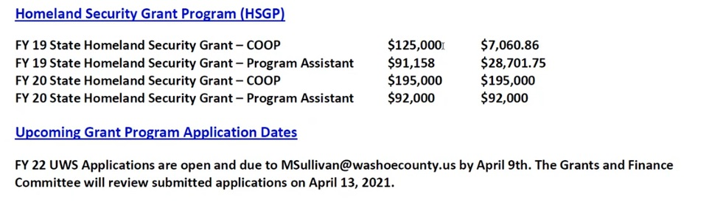
Kelly Echeverria noted LEPC will be doing another COOP and apply for another Homeland Security Grant-Program Assistant.
7. COMMITTEE MEMBER AND STAFF ANNOUNCEMENTS, REQUESTS FOR INFORMATION AND SELECTION OF TOPICS FOR FUTURE AGENDAS.
There was no comment.
8. PUBLIC COMMENT –
There was no public comment.
9. Eric Millette adjourned meeting at 11:55am.

