**Registro de Químico Desinfectante/Lavavajillas**



Concentrados Químicos*: Cloro = 50-100 ppm Amonio Cuaternario (Cuat) -200 -400 ppm

**Se deben de tomar acciones correctivas si no se cumple con el requisito de la concentración del químico.**

|  |  |  |  |  |
| --- | --- | --- | --- | --- |
| Fecha | Hora | Iniciales | Concentración del Químico (ppm) | Acción Correctiva a Tomar (si se necesita) |
|  |  |  |  |  |
|  |  |  |  |  |
|  |  |  |  |  |
|  |  |  |  |  |
|  |  |  |  |  |
|  |  |  |  |  |
|  |  |  |  |  |
|  |  |  |  |  |
|  |  |  |  |  |
|  |  |  |  |  |
|  |  |  |  |  |
|  |  |  |  |  |
|  |  |  |  |  |
|  |  |  |  |  |
|  |  |  |  |  |
|  |  |  |  |  |
|  |  |  |  |  |
|  |  |  |  |  |
|  |  |  |  |  |
|  |  |  |  |  |
|  |  |  |  |  |
|  |  |  |  |  |
|  |  |  |  |  |
|  |  |  |  |  |
|  |  |  |  |  |
|  |  |  |  |  |

Revisado Por: _________________________________

ENVIRONMENTAL HEALTH SERVICES

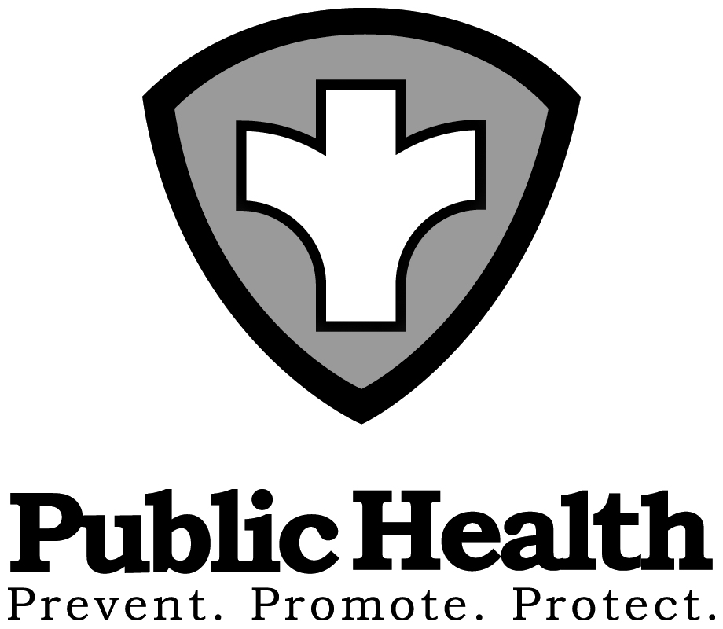

1001 East Ninth Street I P.O. Box 11130 I Reno, Nevada 89520

775-328-2434 I Fax: 775-328-6176 I washoecounty.us/health

Serving Reno, Sparks and all of Washoe County, Nevada | Washoe County is an Equal Opportunity Employer