Electronic Permit Standards

Washoe County Building Division Electronic Permit Submittal

# Cover Sheet

For plan sheets sized at 24” x “36” of greater (30” x 42”), a 3” x 3” approval box, located on the lower right quadrant of the cover sheet is required for multiple divisional review approval.



For plan sheets sized 11” x 17”, a 2”x 1” approval box, located anywhere on the cover sheet is required for multi divisional review approval.

Building – DBM

Planning – DBM

Engineering – DBM

Fire – DBM

 

Planning – DBM

Building – DBM

# Title Block

For plan sheets sized 24” x “36” of greater (30” x 42”), a 2” x 2” approval box, located directly above plan sheet numbering box must be located on the title block of all pages to allow final Washoe County approval.

 

For plan sheets sized at 11”x17”, a 1”x1” approval box, located directly above plan sheet numbering box, must be located on the title block of all pages to allow for final Washoe County approval.

# Scale

PDF plans must be generated at a prescribed scale (e.g. ¼” =1’-0”, or 1” =20’) for plan review to be able to verify dimensions and areas of each plan using the Acrobat measuring tool.

# Page Orientation

All plan sheets must be oriented, so the top of the page is always at the top of the monitor and set to landscape. A north arrow must be provided.

# Page Size

## Plan Sheets

All plan sheets must use a 24”x36” standard size.

The following permit types can use a 11”x17” paper size.

* Solar
* Signs
* Residential Patio Covers
* Single Family Master Repeats

## Associated Documents

All related associated documents (i.e. Truss and Structural Calculations, Energy Calculations, Geo-Technical Soils Reports, etc.…) can be submitted in 8”x11” size.

# Document Security Settings

There must not be any document restrictions on any file that is submitted for review. To make sure no document restrictions have been set, from the File tab in Adobe Acrobat, select Properties. Document Properties window will open. Select the Security Tab. All actions should be shown as, “Allowed”.

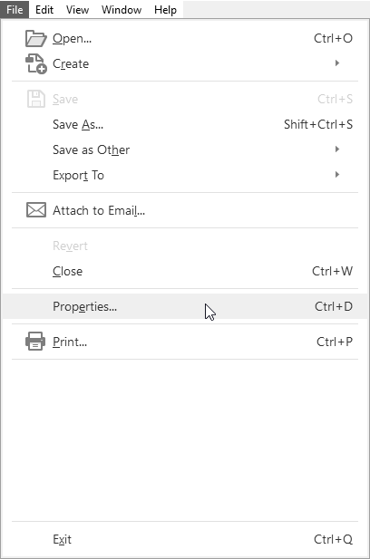

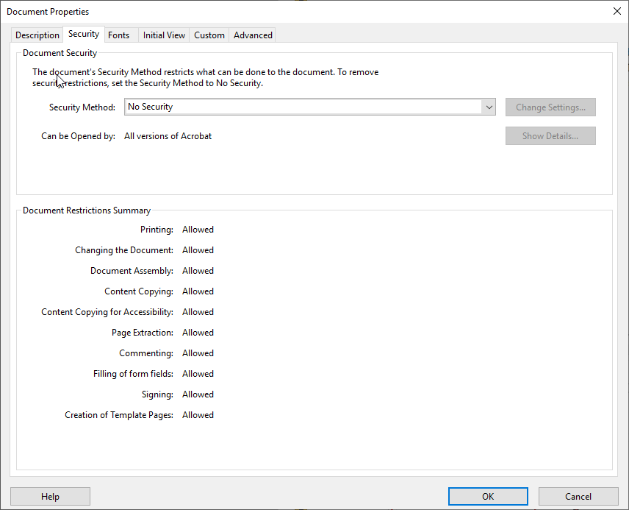

# Bookmarks

All plan sheets must be individually bookmarked with page number and description. From the bookmark tool, you can view the existing bookmarks.

All sheet numbers and sheet titles listed on sheet index must be bookmarked.

**Documents other than plans do not need to be bookmarked.**

# File Naming

All uploaded documents must be named in the following formats:

## Initial Review

|  |  |
| --- | --- |
| Sheet Type | File Naming Convention |
| Plans/Site Plans | <PROJECT NAME>_PLANS |
| Structural Calcs | <PROJECT NAME>_ECALCS |
| Energy Compliance | <PROJECT NAME>_ENERGY |
| Geotech Report | <PROJECT NAME>_GEOTECH |
| Truss Calculations (Floor & Roof) | <PROJECT NAME>_TCALCS |
| Truss Verification Letter | <PROJECT NAME>_TRUSS_VER |
| Special Inspections | <PROJECT NAME>_SP_INSP |
| Mechanical Equipment Sizing | <PROJECT NAME>_MECH_EQUIP |
| MFR’s Installation Instructions | <PROJECT NAME>_MFR_SPECS |
| Hydrology Report | <PROJECT NAME>_HYDRO_RPT |
| Miscellaneous | <PROJECT NAME>_MISC |
| Master Matrix | <PROJECT NAME>_MATRIX |
| TRPA | <PROJECT NAME>_TRPA |

**Example:** Site Plans for the Doral Academy would be named, **DoralAcademy_PLANS.pdf**

## Subsequent Reviews

### Revisions

|  |  |
| --- | --- |
| Sheet Type | File Naming Convention |
| Plans/Site Plans | <PROJECT NAME>_PLANS_REV<Revision number> |
| Structural Calcs | <PROJECT NAME>_ECALCS_REV<Revision number> |
| Energy Compliance | <PROJECT NAME>_ENERGY_REV<Revision number> |
| Geotech Report | <PROJECT NAME>_GEOTECH_REV<Revision number> |
| Truss Calculations (Floor & Roof) | <PROJECT NAME>_TCALCS_REV<Revision number> |
| Truss Verification Letter | <PROJECT NAME>_TRUSS_VER_REV<Revision number> |
| Special Inspections | <PROJECT NAME>_SP_INSP_REV<Revision number> |
| Mechanical Equipment Sizing | <PROJECT NAME>_MECH_EQUIP_REV<Revision number> |
| MFR’s Installation Instructions | <PROJECT NAME>_MFR_SPECS_REV<Revision number> |
| Hydrology Report | <PROJECT NAME>_HYDRO_RPT_REV<Revision number> |
| Miscellaneous | <PROJECT NAME>_MISC_REV<Revision number> |
| Master Matrix | <PROJECT NAME>_MATRIX_REV<Revision number> |
| TRPA | <PROJECT NAME>_TRPA_REV<Revision number> |

**Example:** First revision to Site Plans for the Doral Academy would be named, **DoralAcademy_PLANS_REV1.pdf**

### Corrections

|  |  |
| --- | --- |
| Sheet Type | File Naming Convention |
| Plans/Site Plans | <PROJECT NAME>_PLANS_CORR<Correction number> |
| Structural Calcs | <PROJECT NAME>_ECALCS_ CORR< Correction number> |
| Energy Compliance | <PROJECT NAME>_ENERGY_ CORR< Correction number> |
| Geotech Report | <PROJECT NAME>_GEOTECH_ CORR< Correction number> |
| Truss Calculations (Floor & Roof) | <PROJECT NAME>_TCALCS_ CORR< Correction number> |
| Truss Verification Letter | <PROJECT NAME>_TRUSS_VER_ CORR< Correction number> |
| Special Inspections | <PROJECT NAME>_SP_INSP_ CORR< Correction number> |
| Mechanical Equipment Sizing | <PROJECT NAME>_MECH_EQUIP_ CORR<Revision number> |
| MFR’s Installation Instructions | <PROJECT NAME>_MFR_SPECS_ CORR<Revision number> |
| Hydrology Report | <PROJECT NAME>_HYDRO_RPT_ CORR<Revision number> |
| Miscellaneous | <PROJECT NAME>_MISC_ CORR<Revision number> |
| Master Matrix | <PROJECT NAME>_MATRIX_ CORR<Revision number> |
| TRPA | <PROJECT NAME>_TRPA_CORR<Revision number> |

**Example:** First correction to Site Plans for the Doral Academy would be named, **DoralAcademy_PLANS_CORR1.pdf**

# File Size

Each document will be limited to 200MB in size. Please make sure enough time is being allowed for documents to completely upload. To check the size of each file, from Adobe select the File menu and then Properties. The document properties will be displayed.



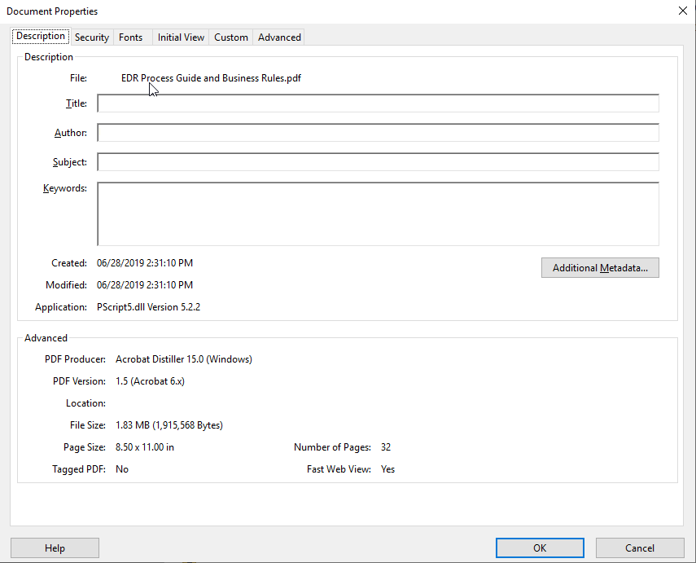

# Layers

All documents submitted must be free of layers. Layers can slow the processing of the file as it increases the overall size. Follow these steps to ensure layers have been flattened in each document:

* Select the layers tool located on the left side of the screen. 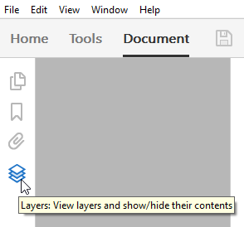
* If layers are shown, select the Options tool within layers and then select Flatten Layers. 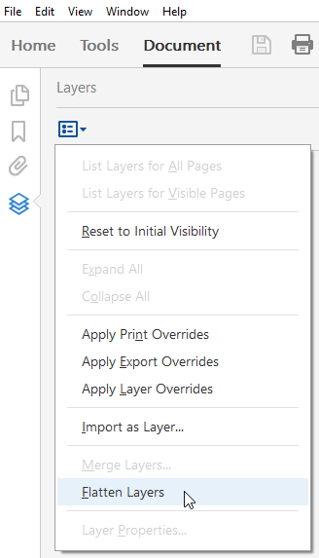

# File Type

All files must be in Portable Document Format (.PDF) and compatible with Adobe Acrobat 10 or newer. Use the document properties window to view the version of the document.

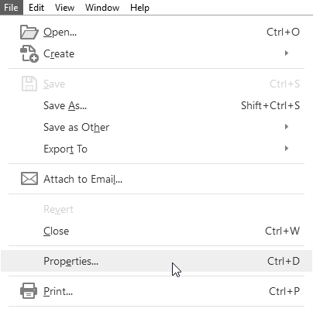



If the PDF document was created in a version of Adobe Acrobat older than version 10, it will need to be optimized for Acrobat 10. To optimize the document, do the following:

* Open the document in Adobe Acrobat. Click the File menu and select Save As Other, then select Optimized PDF…

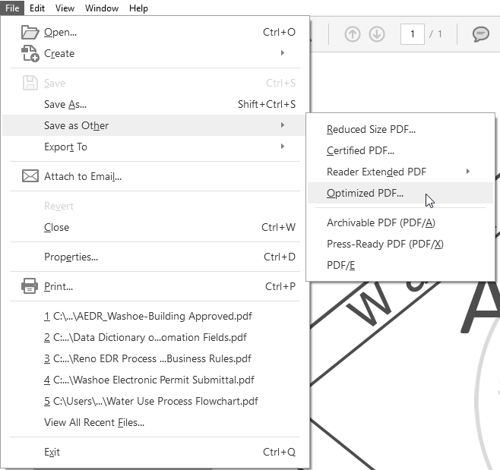

* The PDF Optimizer window will open. Click the “Make compatible with” drop down menu and select Acrobat 10.0 or later from the list. Then click OK 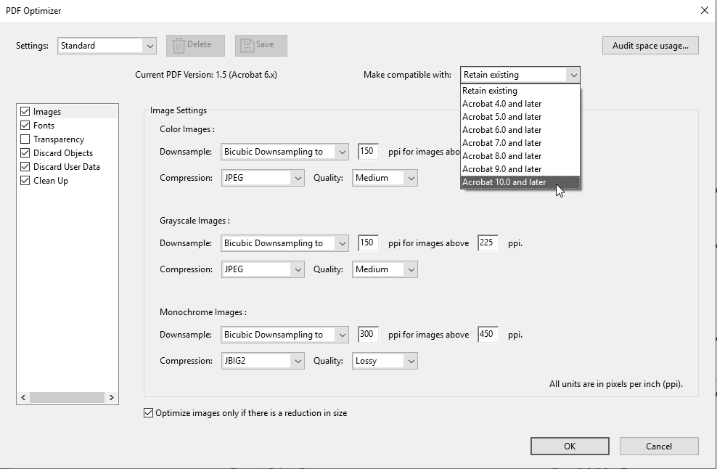
* A save window will open. Determine the save location, name the file accordingly, and click Save. 