How to Register for Login.gov account
https://www.login.gov/help/get-started/create-your-account/

How to verify SAM.gov registration for federal procurement.
- SAM.gov
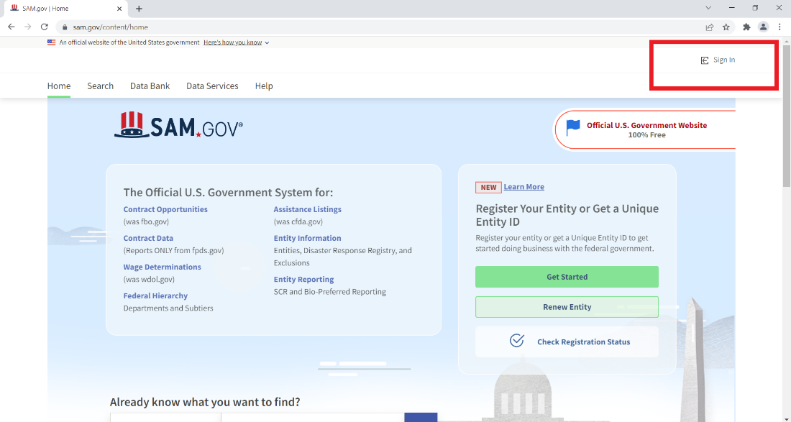
- Login using your Login.gov account
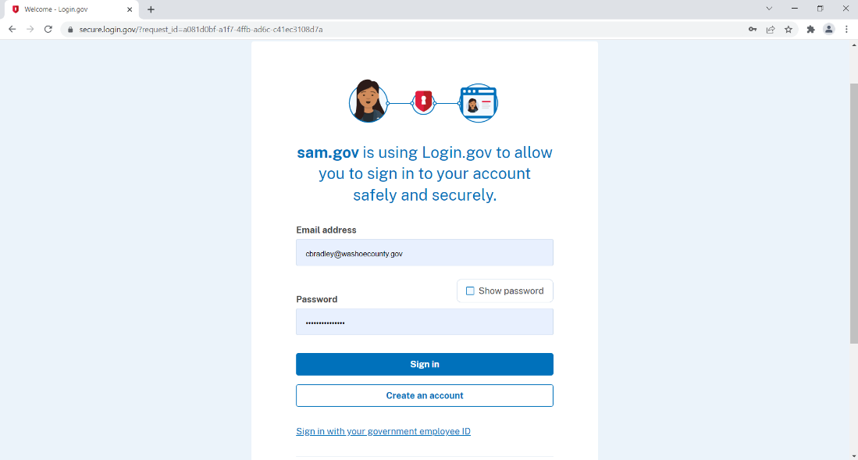
- Click on the Search Button
- Change the Search Criteria to “Any Words”
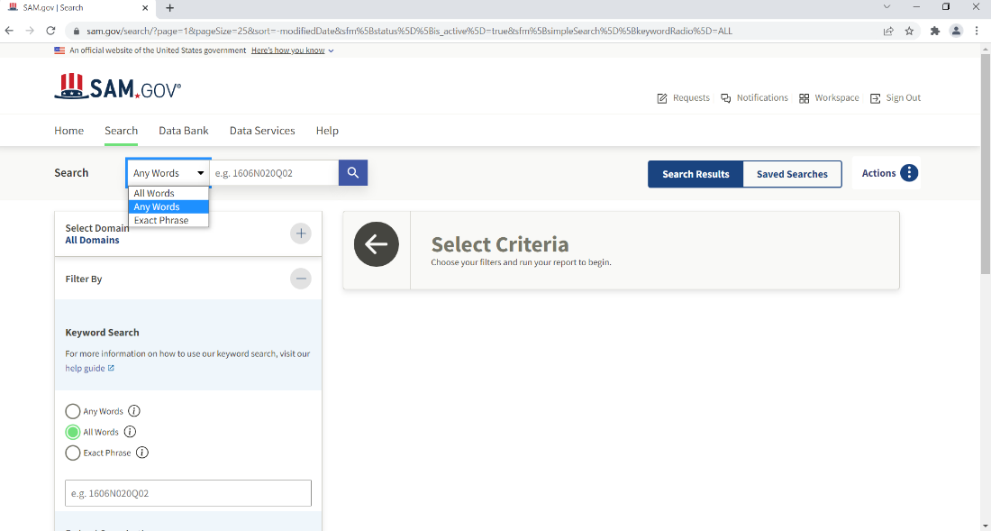

- Click on the + next to Select Domain
- Select Entity Information
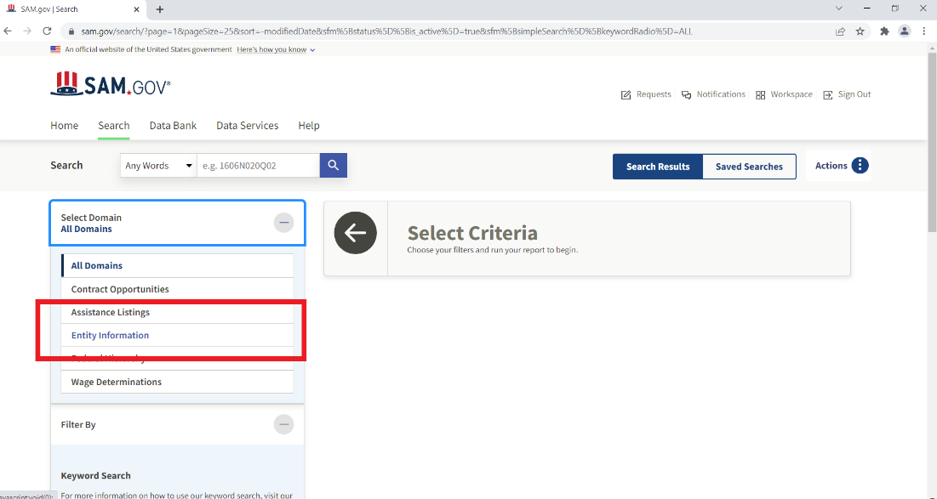
- Using the vendor’s UEI or name, you can search in the search bar.
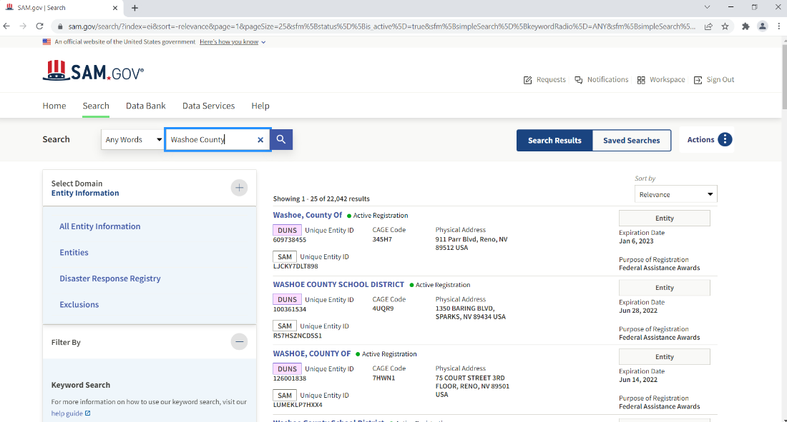
- Scroll to find the entity that you are looking for and select the name. The entity’s profile will look like this. Download the report as a pdf.
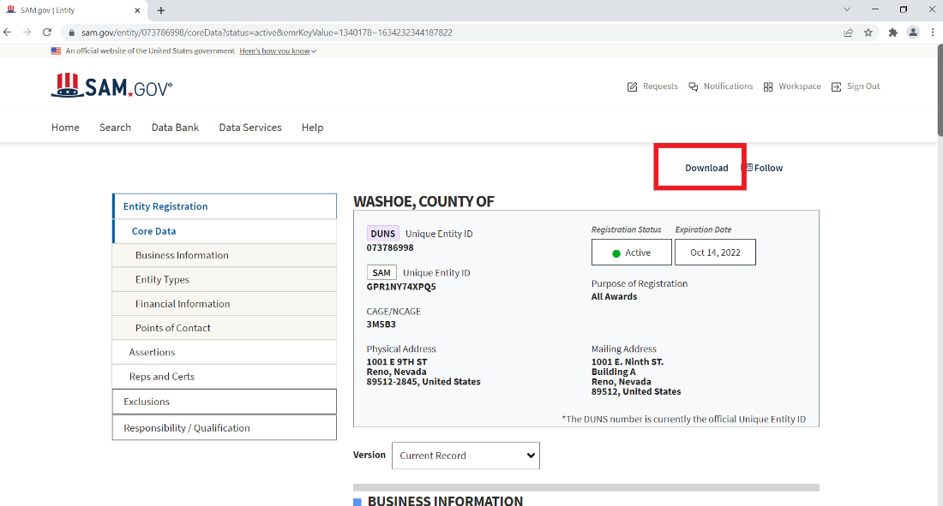
- The report will look like this:
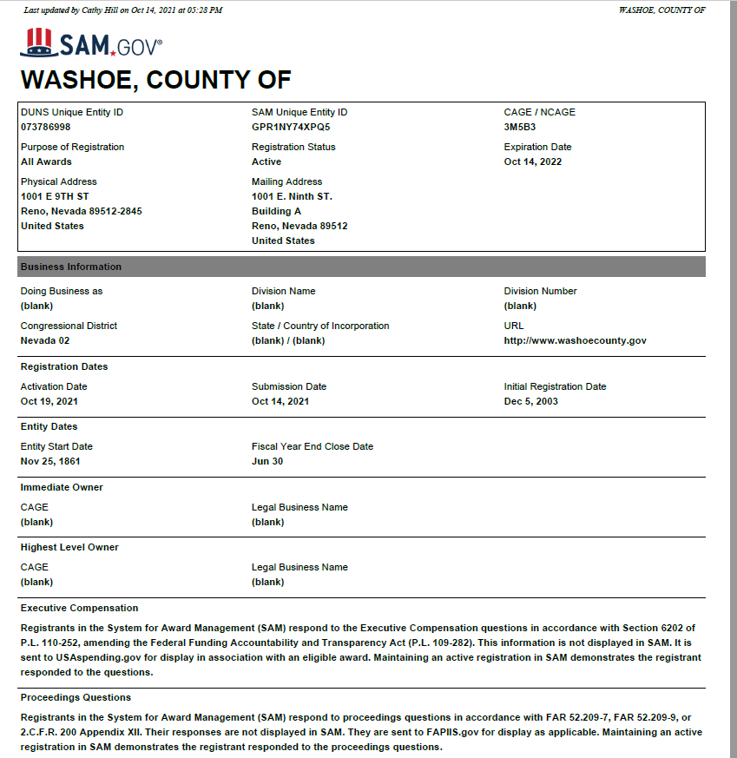
- Scroll to the Exclusion Summary to ensure that the entity is eligible to receive federal funds.
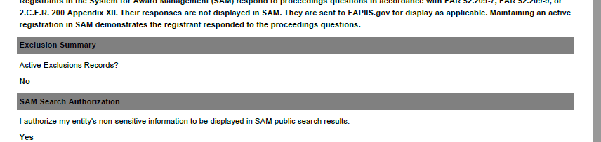
If the vendor has an active registration and is not excluded from federal funding, attach the pdf to the PO Requisition.

Registration
If an entity is not registered on SAM.gov, please work with the vendor to follow these steps:
- Search https://sam.gov/content/entity-registration
- Request a DUNS Number
  - Click Go to D&B web form
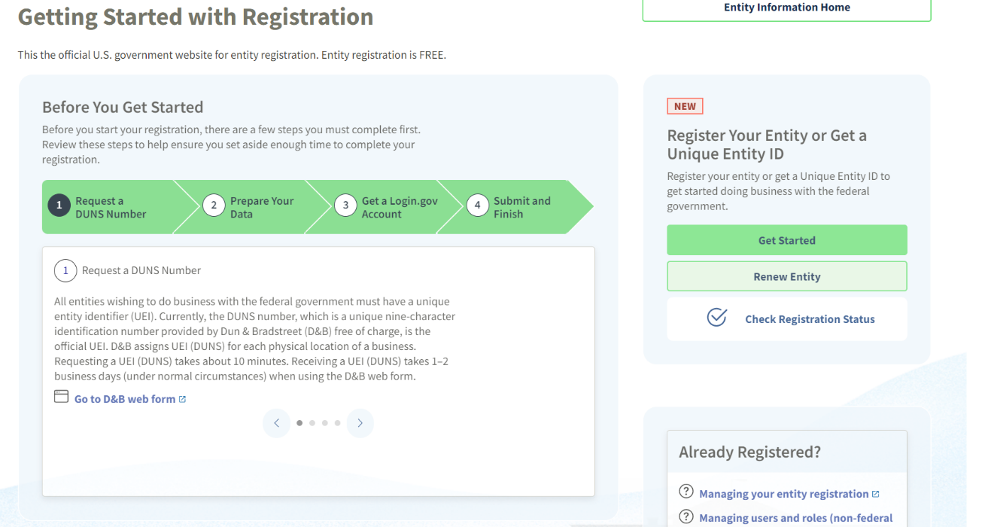
- Enter your company information
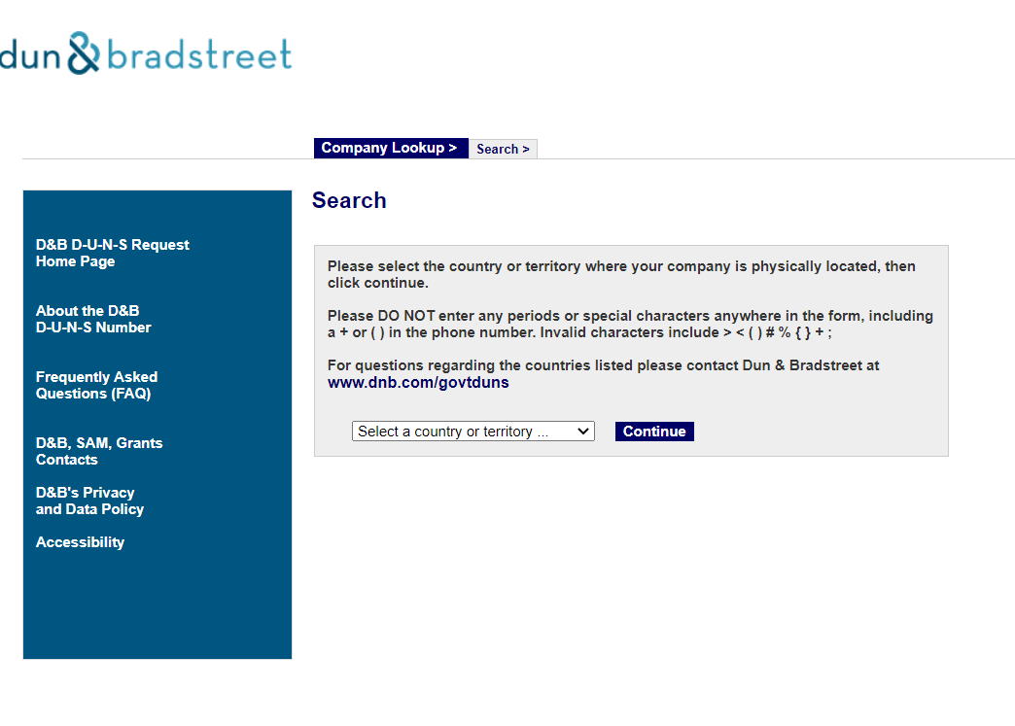
- Prepare Your Data
  - (Follow the SAM Registration Steps) This could take a few days.

