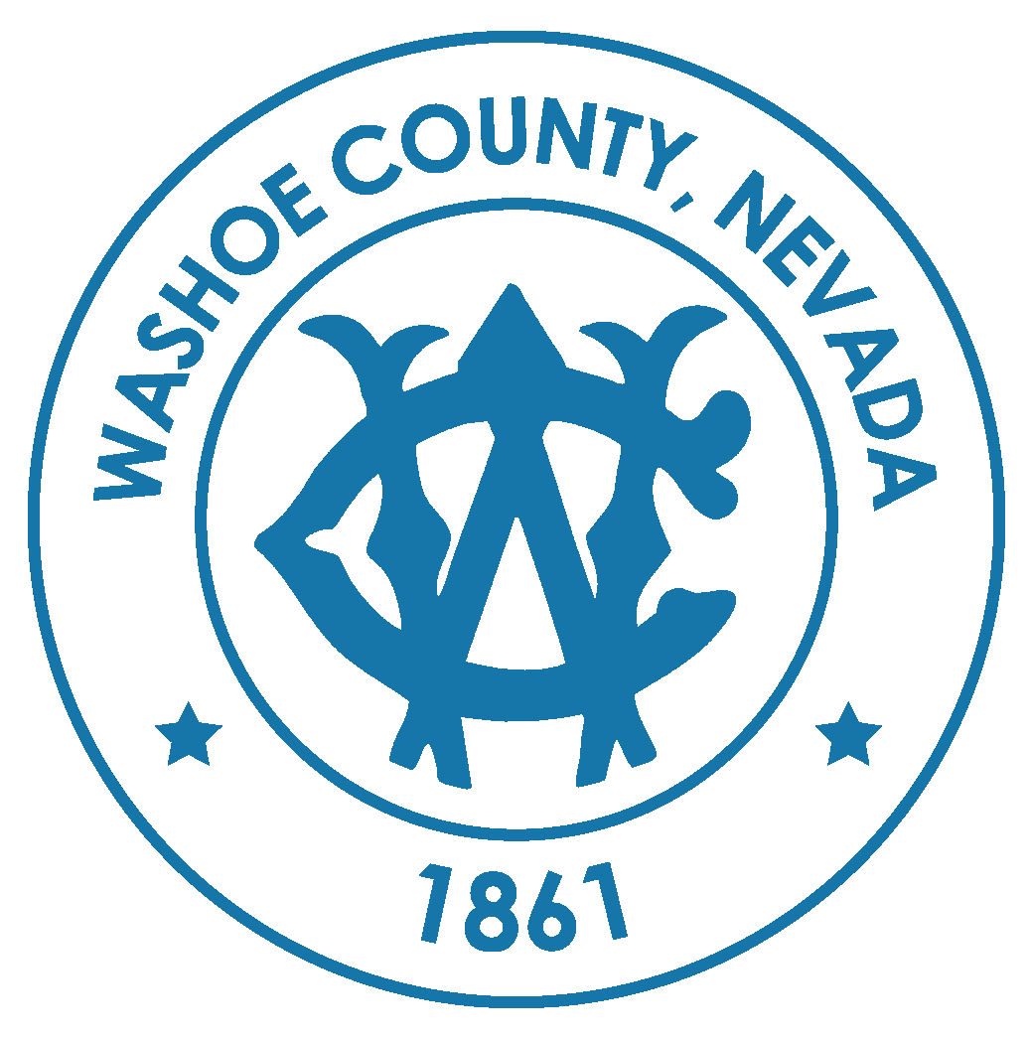
Warm Springs/Rural
Citizen Advisory Board Meeting Agenda
January 10, 2024 at 6:00 P.M.
Regional Shooting Facility, 21555 Pyramid Highway, Palomino Valley
Zoom: https://washoecounty-gov.zoom.us/j/99188159948
NOTE: Items on this agenda may be taken out of order, combined with other items, discussed or voted on as a block, removed from the agenda, or moved to another agenda of another later meeting at the discretion of the Chair. Citizen Advisory Boards act in an advisory capacity only. Issues of concern noted by the Citizen Advisory Board shall be presented to the appropriate Washoe County board, commission, department, or agency either in writing or at a public hearing.
Accessibility. The meeting location is accessible to the disabled. If you require special arrangements for the meeting, call the Commission Support Team, (775) 328-2003, two working days prior to the meeting.
Public comment and time limits. Public comments are welcomed during the General Public Comment period for all matters, whether listed on the agenda or not, and are limited to three minutes per person. Additionally, public comment will be heard during individually numbered action items on the agenda. Persons not attending in person, including anyone attending via online option, are invited to submit comments in writing on agenda items to be included in the written record/minutes from the meeting, or attend and make verbal public comment on that item at the Citizen Advisory Board meeting. Public comment, letters, etc. submitted will not be read aloud. Persons may not allocate unused time to other speakers.

Time Limits. Public comments are welcomed during the Public Comment period for all matters, whether listed on or off the agenda, and are limited to three (3) minutes per person or as designated by the Citizen Advisory Board Chair at the beginning of the meeting. Additionally, public comment of three (3) minutes per person will be heard during individually numbered items designated as "for possible action" on the agenda. No action may be taken on a matter raised under general public comment until the matter is included on an agenda as an item on which action may be taken. Persons may not allocate unused time to other speakers.
Forum Restrictions and Orderly Conduct of Business. The Citizen Advisory Board is an advisory body providing community comments and recommendations to Washoe County governing boards. The presiding officer may order the removal of any person whose statement or other conduct disrupts the orderly, efficient or safe conduct of the meeting. Warning against disruptive conduct may or may not be given prior to removal. The viewpoint of a speaker will not be restricted, but reasonable restrictions may be imposed upon the time, place and manner of speech. Irrelevant and unduly repetitious statements and personal attacks which antagonize or incite others are examples of speech that may be reasonably limited.
Responses to Public Comments. The Citizen Advisory Board can deliberate or take action only if a matter has been listed on an agenda properly posted prior to the meeting. During the public comment period, speakers may address matters listed or not listed on the published agenda. The Open Meeting Law does not expressly prohibit responses to public comments by the CAB members. However, responses from CAB members to unlisted public comment topics could become deliberation on a matter without notice to the public. On the advice of legal counsel and to ensure the public has notice of all matters the Citizen Advisory Board will consider, CAB members may choose not to respond to public comments, except to correct factual inaccuracies, ask for County staff clarification, or to ask that a matter be addressed on a future agenda. CAB members may do this either during the public comment item or during the following item "CHAIRMAN/BOARD MEMBER ITEMS".
Posting Locations. Pursuant to NRS 241.020(4)(a), this notice has been posted at 1001 E. 9th Street, Bldg. A, Reno, NV and online at www.notice.nv.gov and www.washoecounty.gov/cabs.
Support Documentation. Support documentation for the items on the agenda, provided to the CAB is available to members of the public by emailing the Commission Support Team at CAB@washoecounty.gov.

AGENDA

1. CALL TO ORDER/ DETERMINATION OF QUORUM [Non-Action Item]
2. PLEDGE OF ALLEGIANCE [Non-Action Item]
3. GENERAL PUBLIC COMMENT – Comment heard under this item will be limited to three (3) minutes per person and may pertain to matters both on and off the agenda. The Citizen Advisory Board will also hear public comment during individual action items, with comment limited to three minutes per person. Comments are to be made to the CAB as a whole. [Non-Action Item]
4. APPROVAL OF THE MINUTES FOR THE MEETINGS OF NOVEMBER 15, 2023 [For Possible Action]
5. PUBLIC SAFETY UPDATE – General Community Update from Truckee Meadows Fire Protection District and/or Washoe County Sheriff’s Office. [Non-Action Item]
6. BUSINESS LICENCING IN WASHOE COUNTY – Sarah Tone, Business Facilitator for Washoe County Community Services Department, will share information about the New Business License Toolkit to simplify the road to running your own business, including common mistakes, and required local and state licenses. [Non-Action Item]
7. INCREASE COMMUNITY PARTICIPATION – Discussion and brainstorm on how to increase engagement and participation of the Warm Springs community in the CAB. [Non-Action Item]
8. NEIGHBORHOOD DEVELOPMENT HUB – Staff to display the online HUB for review by the CAB members and/or attendees to determine if there are new or existing projects for discussion. Specific questions and feedback will be brought back to the appropriate staff for announcement at the next CAB meeting. [Non-Action Item]
9. WASHOE COUNTY COMMISSIONER UPDATE- Washoe County Commissioner Jeanne Herman may be available to provide updated information on discussions and actions by the Board of County Commissioners. [Non-Action Item]
10. CAB MEMBER ANNOUNCEMENTS/REQUESTS — This item is limited to announcements and/or requests for future agenda items by CAB members or the Washoe County Manager Eric Brown. [Non-Action Item]
11. GENERAL PUBLIC COMMENT – Limited to no more than three (3) minutes. Anyone may speak pertaining to any matter either on or off the agenda. The public are requested to submit a Request to Speak form to the Board Chairman. Comments are to be addressed to the Board as a whole. [Non-Action Item]

ADJOURNMENT

