Washoe County Building EZ HVAC Permit

This document will walk through each of the pages of the Washoe Program EZ HVAC Permit. To follow this document, you will need to be a registered user on the www.OneNv.us website and be logged into the site.

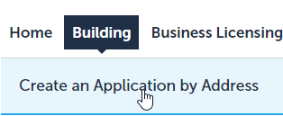
Begin applying for your Permit by selecting the Building Tab and then select Create an Application by Address.

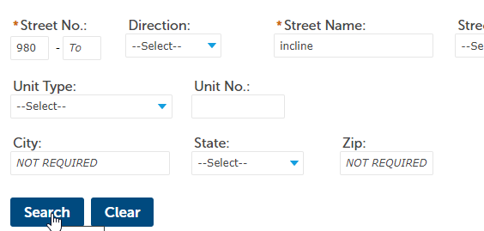
Address Search and Selection
On the Page that opens you will see an address search. Enter the address of the work location. For the best results on the search, only enter the street number, Direction if needed, the street name, and unit number if applicable, leaving the rest of the fields empty. City, State, and Zip Code are not required. Click Search when the address is entered.

When the search is complete you will see a list of addresses just below the search, you may need to scroll down on the page depending on the size of your screen. If more than one address is returned, you can select the correct one by clicking the select link to the right of the correct address. If only one address is returned this is not necessary.
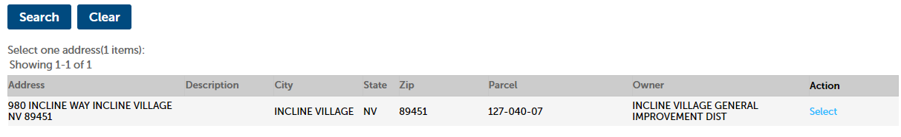
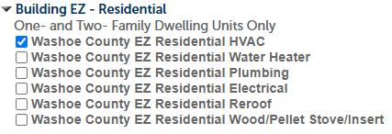
Below the returned addresses is the list of available services for the selected address. Click the Arrow next to Building EZ – Residential and select Washoe County EZ Residential HVAC. Only one permit type should be selected.
Click Continue Application to begin the application process.

Application process:

Address, Parcel, and Owner Page
The first page of the application is a review of the Address, Parcel, and Owner information. This data is pulled from the Accessor’s database and shouldn’t need to be changed. If there has been a change, update the fields and contact the Washoe County Assessor’s office to have the information updated in their records.
Click Continue Application at the bottom of the page when ready.

Application Information Page
The next page is the Application Information page which will display questions regarding your HVAC application. The options selected will determine how the application is processed, and which fees and inspections will be applied.

Incline: Y/N is to determine if the work location is in the Incline Village/ Crystal Bay area or not.
Owner/Builder: Y/N determines if the work will be being done by the Owner of the property or not.
Furnace: Check this box if you are adding or replacing a furnace.
Number of FAUs with 100k BTUs or Less: Enter the number of new or replacement Forced Air Units that are 100k BTUs or less. If there are none, enter 0 in this field.
Number of FAUs with Greater than 100k BTUs: Enter the number of new or replacement Forced Air Units that are greater than 100k BTUs. If there are none, enter 0 in this field.
FAU 1, 2, 3, 4 New/Replacement: These drop-down boxes indicate whether this is a new installation of a furnace or if it is a replacement of an existing unit.
FAU 1,2,3, 4 Exact BTUs: Enter the exact BTUs of the new/replacement furnace.
AC: Check this box if you are adding or replacing an air conditioning unit.
Number of AC units: enter the number of new ac units being entered.
AC Condenser Location: This dropdown indicates whether the AC Unit(s) are located inside or outside.
AC 1,2,3,4 Size: Enter the size of each respective ac unit. This is measured in tons.
AC 1,2,3,4 New/Replacement: These dropdowns indicate if the new ac units are a replacement or not.
Boiler: Check this box if you are adding replacing a boiler
Boiler Size: Use this dropdown to select the general size of the Boiler.
Boiler Exact BTUs: Enter the exact BTUs of the Boiler.
Mini Split/Heat Pump: Check this box if you are adding a mini split or heat pump.
Mini-Split/Heat Pump Quantity: Enter the number of units being installed.
New Gas Line: Select Yes if you are adding new gas lines for any of the above options.
New Ducting: Select Yes if you are adding new ducting for any of the above options.
New Electrical: Select Yes if you are adding a new electrical circuit for any of the above options:
Click Continue application when all the required information is entered.

Applicant and Licensed Professional Page
Applicant. The applicant will be automatically selected based on the contact associated with your OneNv.us account.
Licensed Professional. For the Licensed Professional click the Look Up button, enter search criteria for the contractor who will be doing the work on the job.
Click Continue Application when the needed contacts are added to the record.

Attached Documents Page
If you are an Owner/Builder, you will need to submit an Owner/Builder Affidavit as part of you application. Once any required documents are attached, click the Continue Application button.

Review Page
This page allows you to review the application information. Please review the screen before clicking continue, to make sure that all the information is correct. If anything is missing, click the Edit button next to the section and make the necessary changes.
Read the acknowledgement information at the bottom of the page and if you agree to the information, check the acknowledgement checkbox at the bottom of the page and then click Continue Application when ready to submit your application.

Payment Page
If the permit doesn’t need to be reviewed by the Washoe County Building Program, based on the information you entered regarding the work being done, you will be prompted to pay the permit fees.
Click Check Out and then click Checkout a second time.
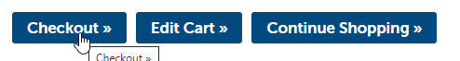
This will open a payment screen.
select either e-check or credit card and fill out the information on the payment screen.
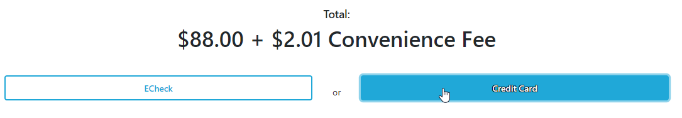
When all the required information is filled out check the boxes at the bottom of the page. There should be one for e-check and two for credit cards. If the pay button is not Green, there is information above that is not filled out or the checkboxes are not checked. Required fields are marked with a red *.
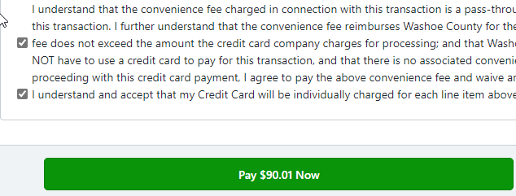
After the payment is made, a receipt dialogue will be displayed, click Print to print out a receipt and continue to complete the process.
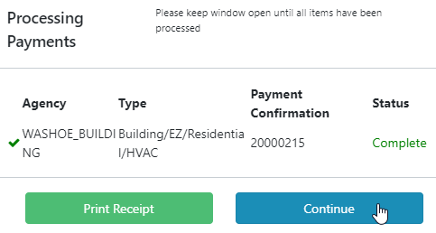
Once the payment has been processed, the permit will be issued, and you will receive an email with the Permit card attached to it.
Scheduling Inspections
When the permit is issued, the inspections required will be added to the permit based on the information provided during the application process. To schedule your inspections, install the free Washoe Building Inspections App on your phone, from either the Apple App Store or the Android Play Store.
Within the Washoe Building Inspections app, enter the address of the permit, permit number, or the contractor’s license number or business name.
On the results screen select the Schedule an Inspection button (The button will only be displayed if the permit is issued).
At the top of the Schedule an Inspection screen, you will see all the Pending section with a list of all the required inspections for the permit. Select the inspection(s) you would like to schedule and click Next at the bottom of the screen, you are able to select multiple inspections at a time.

Select a date on the calendar, this will automatically move the screen forward to the Submit Inspection Screen.
On the Submit Inspection screen include the name, phone number, and email address of someone who will be onsite to meet the Building Inspector at the time of the inspection. Click to Submit to schedule your inspection(s). You will be prompted when the inspections have been scheduled successfully.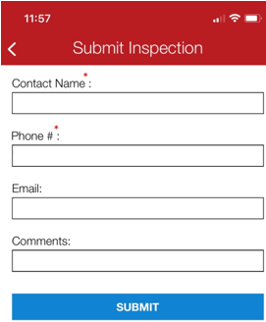

You will receive an email when each inspection has been completed (pass or fail). When all inspections have passed you will receive a final version of the Building Permit Card by email.

