Washoe County Building EZ Electrical

This document will walk through each of the pages of the Washoe Program EZ Electrical Permit. To follow this document, you will need to be a registered user on the www.OneNv.us website and be logged into the site.

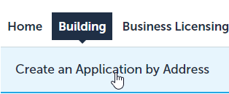Begin applying for your Permit by selecting the Building Tab and then select Create an Application by Address.

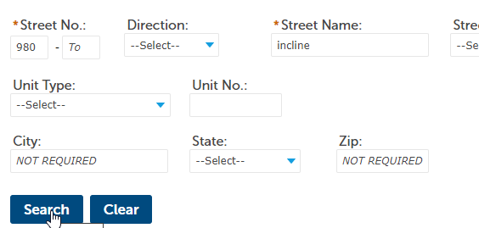Address Search and Selection
On the Page that opens you will see an address search. Enter the address of the work location. For the best results on the search, only enter the street number, Direction if needed, the street name, and unit number if applicable, leaving the rest of the fields empty. City, State, and Zip Code are not required. Click Search when the address is entered.

When the search is complete you will see a list of addresses just below the search, you may need to scroll down on the page depending on the size of your screen. If more than one address is returned, you can select the correct one by clicking the select link to the right of the correct address. If only one address is returned this is not necessary.
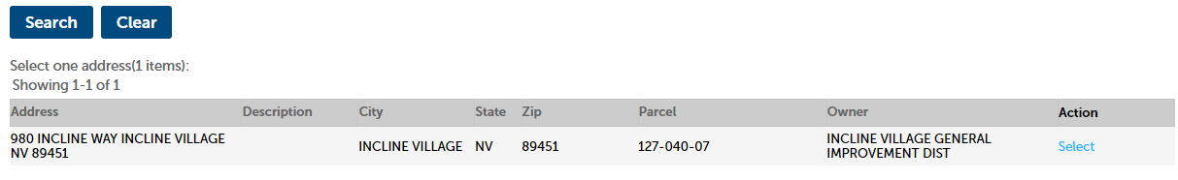

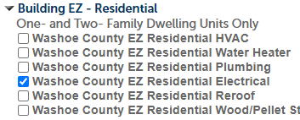Below the returned addresses is the list of available services for the selected address. Click the Arrow next to Building EZ – Residential and select Washoe County EZ Residential Electrical. Only one permit type should be selected.
Click Continue Application to begin the application process.

Application process:

Address, Parcel, and Owner Page
The first page of the application is a review of the Address, Parcel, and Owner information. This data is pulled from the Accessor’s database and shouldn’t need to be changed. If there has been a change, update the fields and contact the Washoe County Assessor’s office to have the information updated in their records.
Click Continue Application at the bottom of the page when ready.

Application Information Page
The next page is the Application Information page which will display questions regarding your electrical application. The options selected will determine how the application is processed, and which fees and inspections will be applied.

Owner/Builder: Y/N determines if the work will be being done by the Owner of the property or not.
Service: Select whether the service is New, Temporary, or an Upgrade.
Power Pole: If there the service will include a power pole, check this box.
Service Amperage: Select whether the service is 200 amps or lower or if it is greater than 200 amps.
Exact Service Amperage: Enter the exact Service Amperage.
Previous Service Amperage: If this is not a new service, enter the previous Service Amperage.
Number of Outlets/Switches: Enter the number of new outlets and switches.
Number of Lights: Ener the number of light fixtures.
New Circuits: Enter the number of new circuits.
Adding Electric to Garage/Accessory Structure?: Select Yes if you are adding electricity to a garage or accessory structure.
Garage/Accessory Structure Square Footage: If you selected Yes for Adding Electric to Garage/Accessory Structure, enter the square footage of the structure.

Click Continue application when all the required information is entered.

Applicant and Licensed Professional Page
Applicant. The applicant will be automatically selected based on the contact associated with your OneNv.us account.
Licensed Professional. For the Licensed Professional click the Look Up button, enter search criteria for the contractor who will be doing the work on the job.
Click Continue Application when the needed contacts are added to the record.

Attached Documents Page
If you are an Owner/Builder, you will need to submit an Owner/Builder Affidavit as part of your application. Once any required documents are attached, click the Continue Application button.

Review Page
This page allows you to review the application information. Please review the screen before clicking continue, to make sure that all the information is correct. If anything is missing, click the Edit button next to the section and make the necessary changes.
Read the acknowledgement information at the bottom of the page and if you agree to the information, check the acknowledgement checkbox at the bottom of the page and then click Continue Application when ready to submit your application.

Payment Page
If the permit doesn’t need to be reviewed by the Washoe County Building Program, based on the information you entered regarding the work being done, you will be prompted to pay the permit fees.
Click Check Out and then click Checkout a second time.
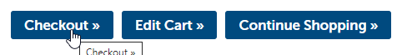
This will open a payment screen.
select either e-check or credit card and fill out the information on the payment screen.
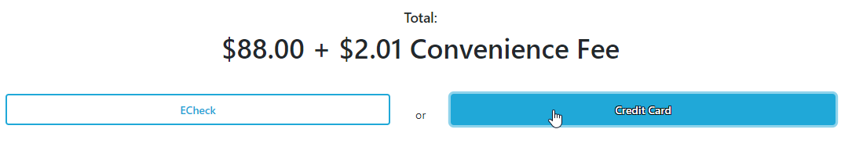
When all the required information is filled out check the boxes at the bottom of the page. There should be one for e-check and two for credit cards. If the pay button is not Green, there is information above that is not filled out or the checkboxes are not checked. Required fields are marked with a red *.
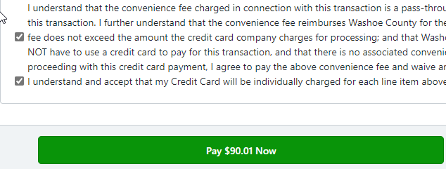
After the payment is made, a receipt dialogue will be displayed, click Print to print out a receipt and continue to complete the process.
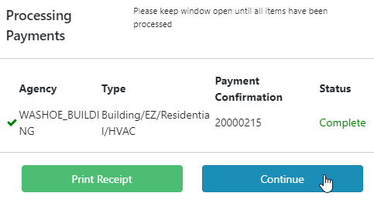
Once the payment has been processed, the permit will be issued, and you will receive an email with the Permit card attached to it.

Scheduling Inspections
When the permit is issued, the inspections required will be added to the permit based on the information provided during the application process. To schedule your inspections, install the free Washoe Building Inspections App on your phone, from either the Apple App Store or the Android Play Store.
Within the Washoe Building Inspections app, enter the address of the permit, permit number, or the contractor’s license number or business name.
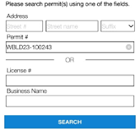
On the results screen select the Schedule an Inspection button (The button will only be displayed if the permit is issued).
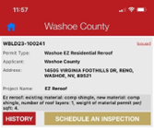
At the top of the Schedule an Inspection screen, you will see all the Pending section with a list of all the required inspections for the permit. Select the inspection(s) you would like to schedule and click Next at the bottom of the screen; you are able to select multiple inspections at a time.
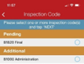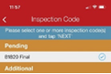

Select a date on the calendar, this will automatically move the screen forward to the Submit Inspection Screen.
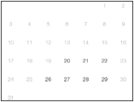
On the Submit Inspection screen include the name, phone number, and email address of someone who will be onsite to meet the Building Inspector at the time of the inspection. Click to Submit to schedule your inspection(s). You will be prompted when the inspections have been scheduled successfully.
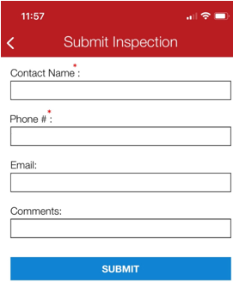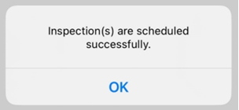

You will receive an email when each inspection has been completed (pass or fail). When all inspections have passed you will receive a final version of the Building Permit Card by email.

